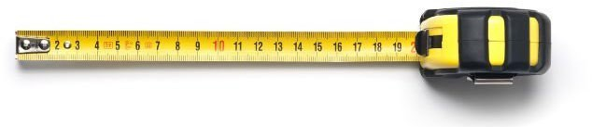

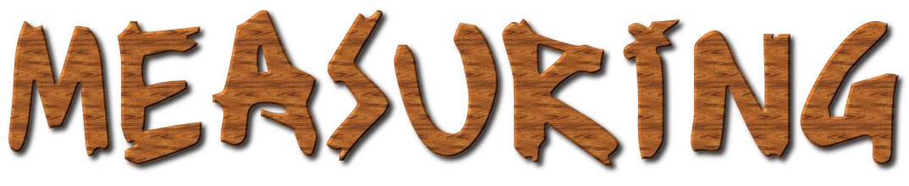
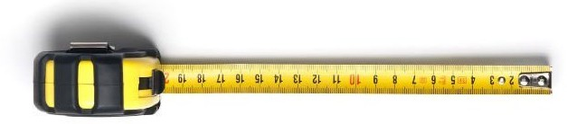
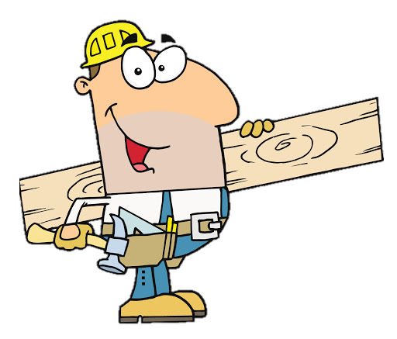



Name: |  | Class:


A=
B=
C=
D=

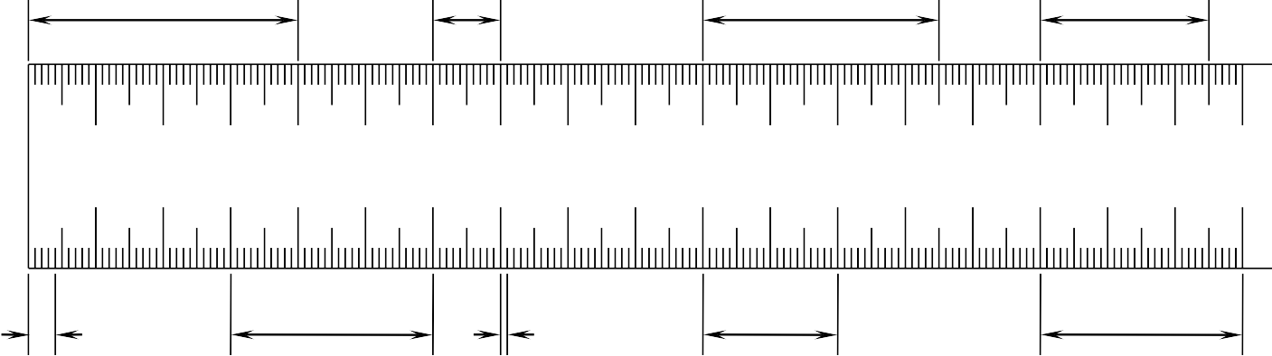
10 20 30 40
50
60 70 80
90 100
110 120 130 140 150 160 170
E=
F=
G=
H=
I=

J=
K=
L=
M=

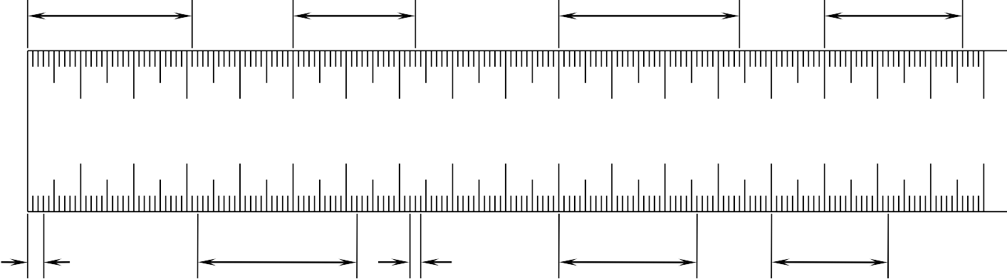
10 20 30 40
50
60 70 80
90 100
110 120 130 140 150 160 170
N=
O=
P=
Q=
R=

S=
T=
U=
V= W=

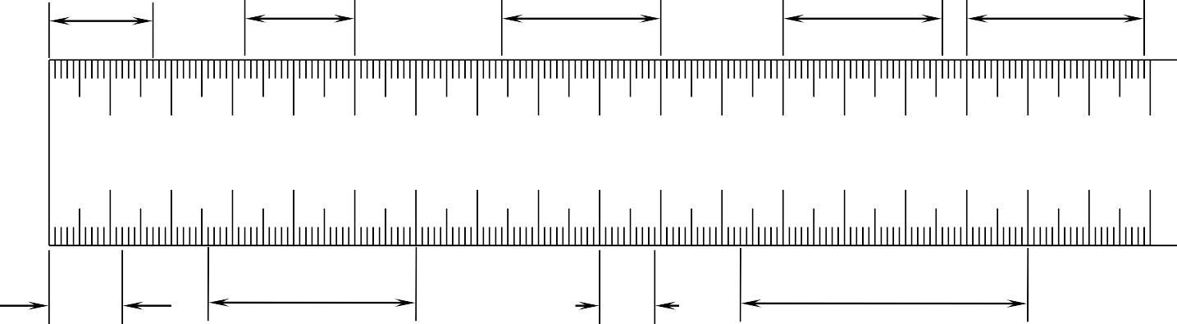
10 20 30 40
50
60 70 80
90 100
110 120 130 140 150 160 170
X=
Y=
Z=
AA=

BB=
CC=
DD=
EE=

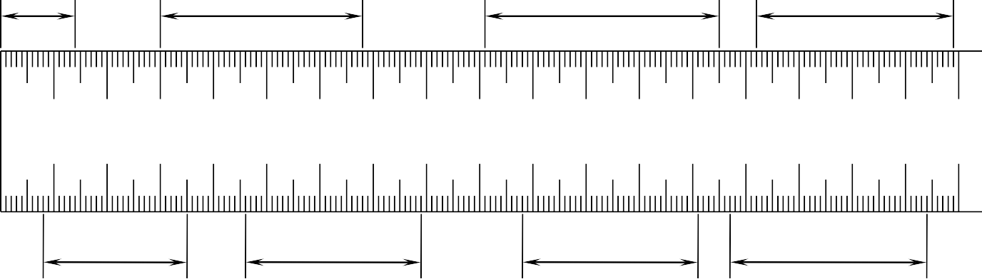
10 20 30 40
50
60 70 80
90 100
110 120 130 140 150 160 170
FF=
GG=
HH=
II=

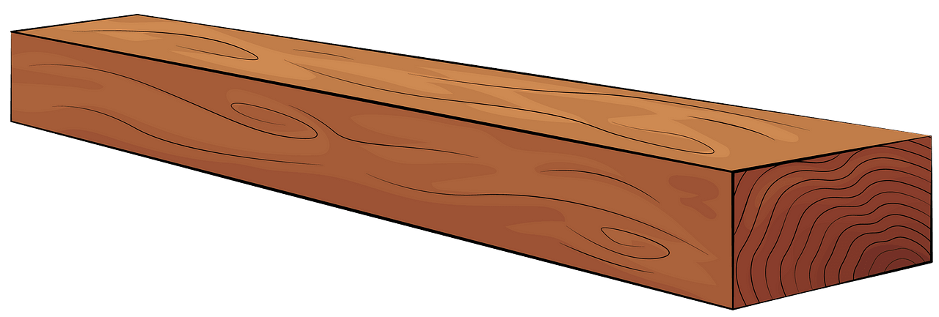


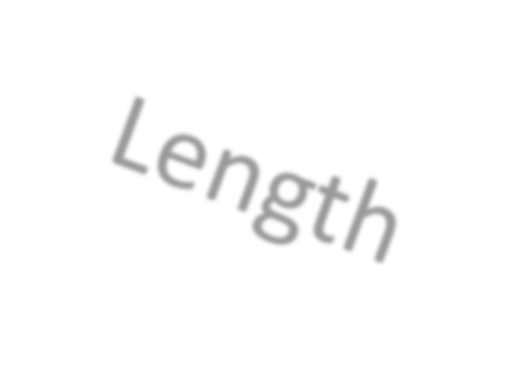


Thickness
When measuring a piece of timber, it is important to first identify the:
1) End Grain 2) Face Grain 3) Edge Grain
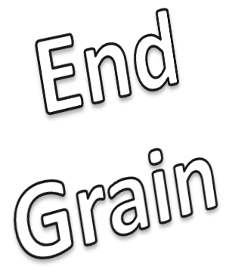
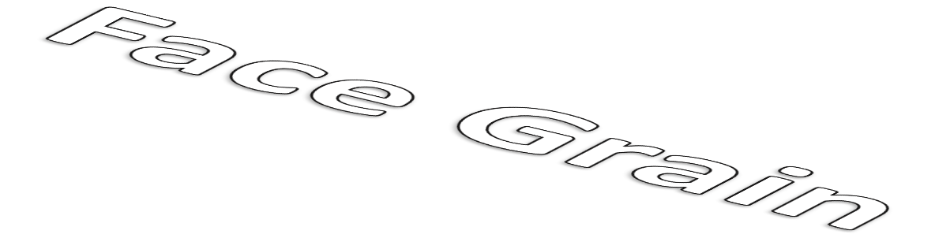

To identify which side is the end grain, look for the growth rings! These are the rings that show you how old the tree is.

When measuring a piece of timber, the first thing to do is measure across the end grain along the widest part, this will give you your Width. Then measure across the end grain in the other direction to find your Thickness. Once you have figured this out, you can then measure away from the end grain to get your Length.

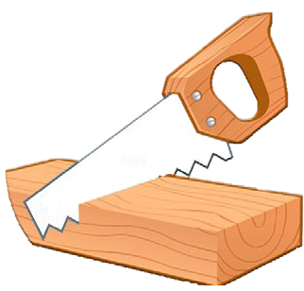
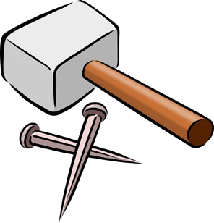
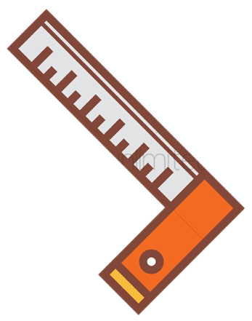
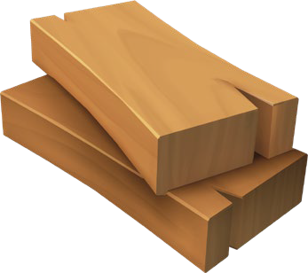
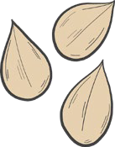
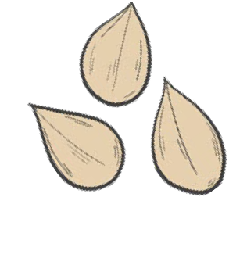


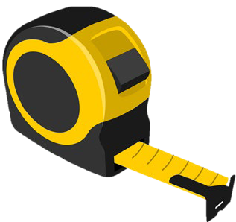

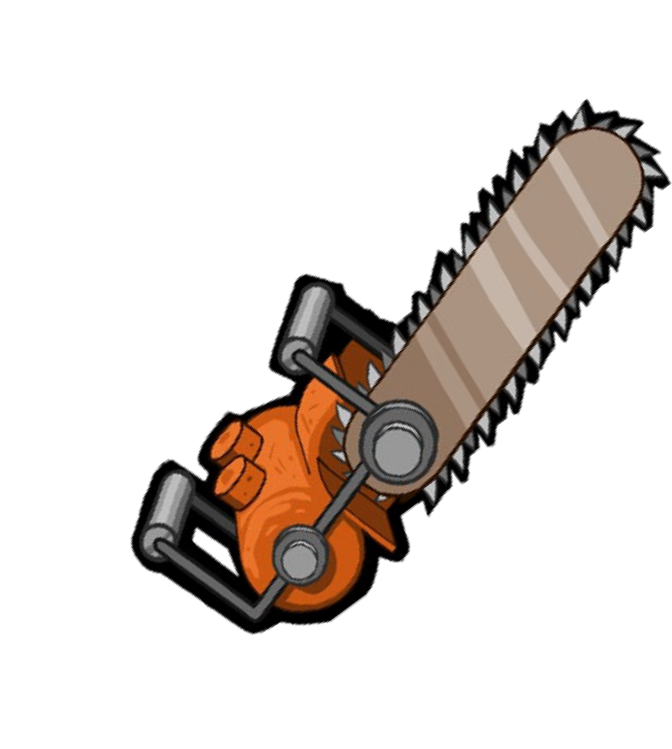
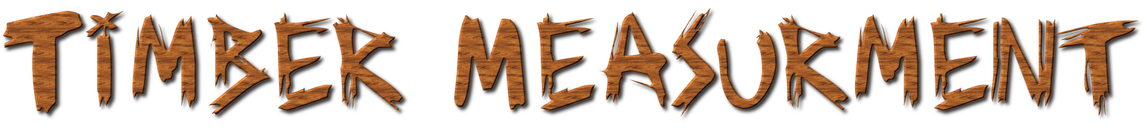

Piece | Width (mm) | Thickness (mm) | Length (mm)
A
B
C
D
E
F
G
H
I
J
K
L
M





Piece | Width (mm) | Thickness (mm) | Length (mm)
N
O
P
Q
R
S
T
U
V
W
X
Y
Z










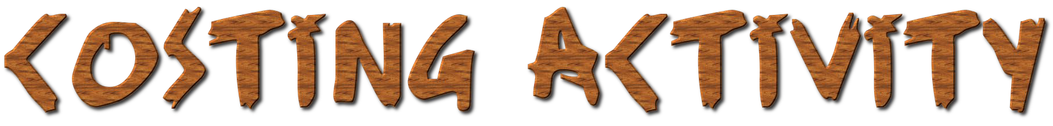
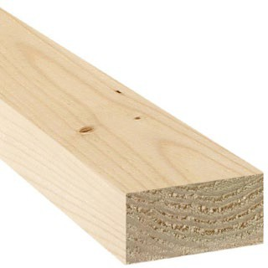
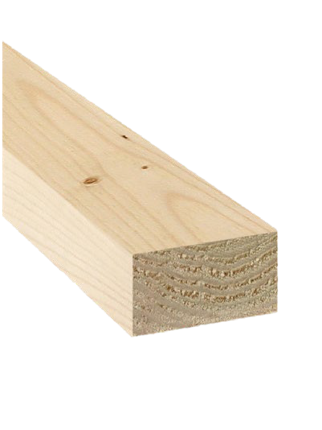
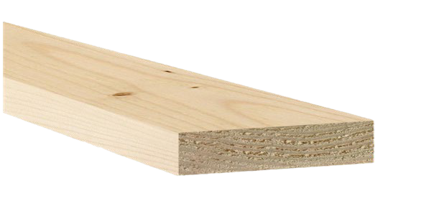
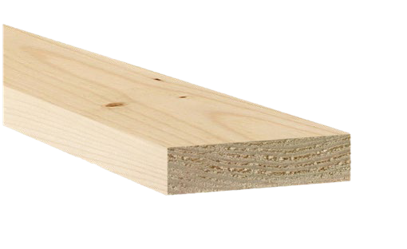
Below are the Lineal Metre prices (how much it costs to buy 1 metre) of common timber sizes found in the workshop.
35
70
45
90
19
140
19
95











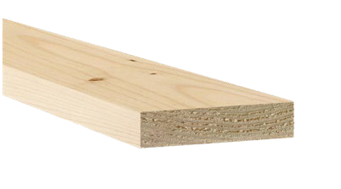
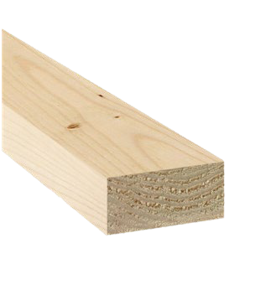
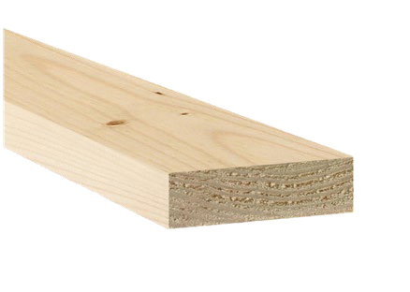
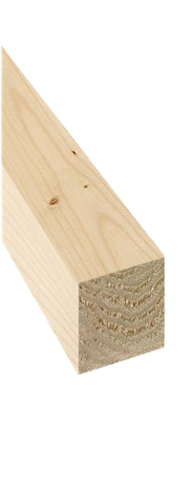
19
65
19
42
19
19
12
70

To figure out the actual cost of the pieces you measured, you will have to:
- Put the length of each piece in mm in the first column.
- Convert the Length from mm to m. Which is easy! All you have to do is divide it by 1000! Put the answer in the second column.
- Put in the lineal metre (L/m) price of each piece in the third column.
- Multiply the length (m) by the lineal metre (L/m) price and put the answer in the fourth column.

Piece | Length (mm) |  | Length (m) |  | L/m Price | Actual Cost for Piece
A
A | 70 | ÷ 1000 |  | 0.07 | X $2.85 = | $0.20
B
C
D
E
F
G
H
I
J
K
L
M

To figure out the actual cost of the pieces you measured, you will have to:
- Put the length of each piece in mm in the first column.
- Convert the Length from mm to m. Which is easy! All you have to do is divide it by 1000! Put the answer in the second column.
- Put in the lineal metre (L/m) price of each piece in the third column.
- Multiply the length (m) by the lineal metre (L/m) price and put the answer in the fourth column.

Piece | Length (mm) |  | Length (m) |  | L/m Price | Actual Cost for Piece
N
N | 190 | ÷ 1000 |  | 0.19 | X $3.86 = | $0.73
O
P
Q
R
S
T
U
V
W
X
Y
Z


For this activity, you will first need to measure all the pieces of plywood in the box.
Piece | Length (mm) | Width (mm) | Thickness (mm)
1
2
3
4
5
6
7
8
9
10
11
12
13
14
15

In the workshop we cant buy small pieces of plywood, we have to buy a big sheet and cut it up into smaller pieces. The sheets we buy are 2400mm x 1200mm and come in different thicknesses.




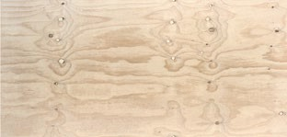
2400
1200
Thickness
Cost per Sheet
19

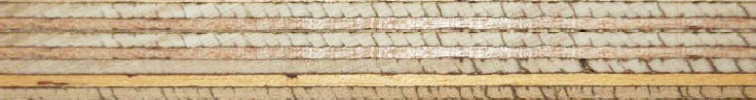


15



12



7



3

To figure out the actual cost of the small pieces of plywood you measured, you will have to:
2400
19mm Thick
1200
179
94
1

X =
Area of Large Sheet
Cost of Piece
Cost of Sheet
Area of Small Piece

So to figure out the cost of Piece 1:
X =
(2400 x 1200)
$0.51
$88
(179 x 94)

X =
(179x94)
Area of Large Sheet
Cost of Piece
Cost of Sheet
Area of Small Piece

# |  | Working Out
1 |  | X $88 = $0.51
 | (2400x1200)
2 |  | X =
3 |  | X =
4 |  | X =
5 |  | X =
6 |  | X =
7 |  | X =
8 |  | X =

# |  | Working Out
9 |  | X =
10 |  | X =
11 |  | X =
12 |  | X =
13 |  | X =
14 |  | X =
15 |  | X =

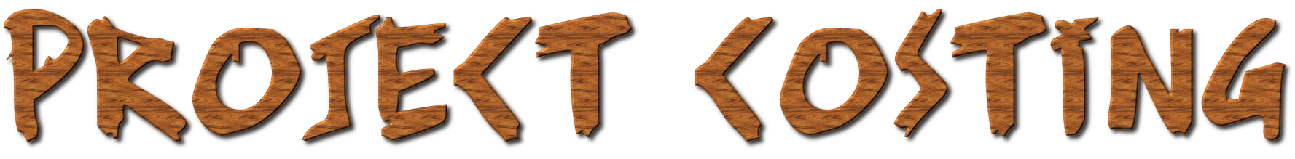
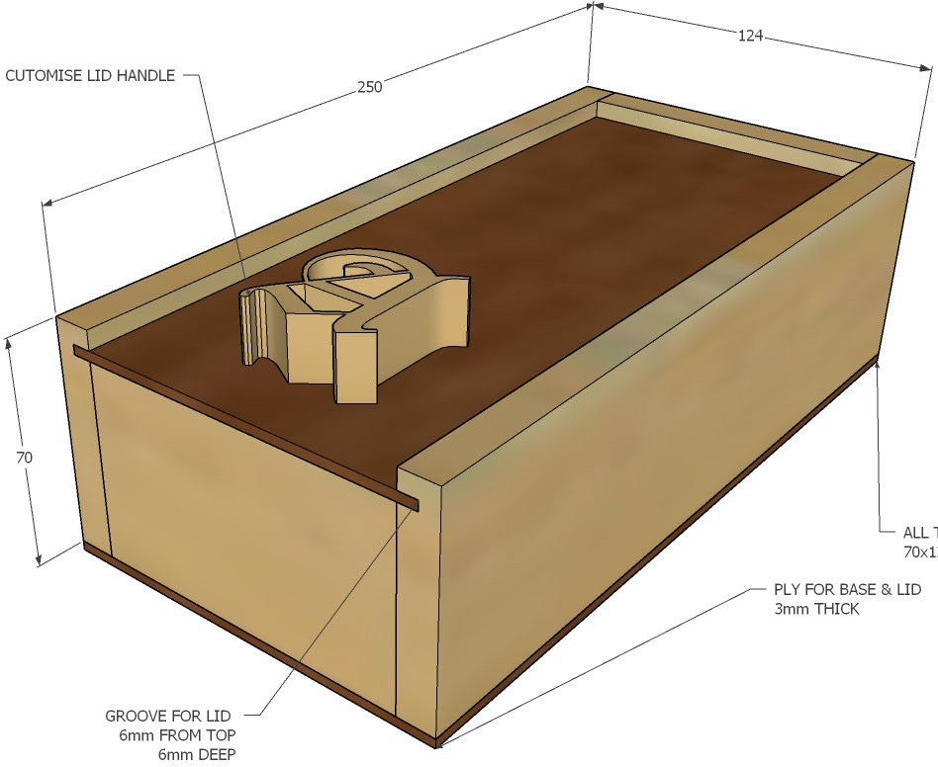
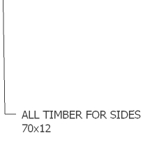
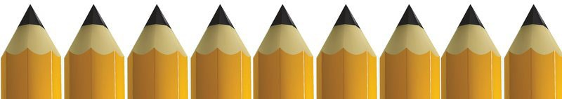

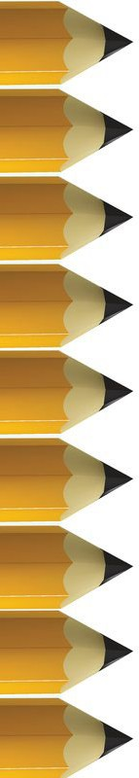
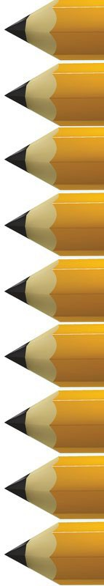
To figure out the cost of the Pencil Box, first measure each piece:

Piece | Length (mm) | Width (mm) | Thickness (mm)
Left
Right
Front
Back
Lid
Base
Then calculate the cost of each piece:

Piece | Length (mm) |  | Length (m) |  | L/m Price | Actual Cost for Piece
Left
Left |  | ÷ 1000 |  | X =
Right
Front
Back

Lid Base
X = Then add together the cost for each
piece and that will tell you how much the pencil box will cost to make!
X =



