Engineering Studies
Preliminary Course: Module 3

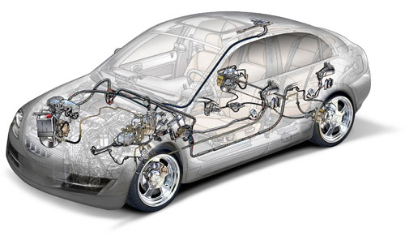

Braking Systems
Student Workbook

Engineering application module 3: Braking systems

30 hours indicative time
Select one or more products related to braking systems as an introduction to engineering applications. Some examples include: the band brake, drum brake, disc brake, anti-lock braking systems (ABS) and regenerative braking systems, as well as the automotive handbrake.

Outcomes

A student:
P1.1 identifies the scope of engineering and recognises current innovations
P2.1 describes the types of materials, components and processes and explains their implications for engineering development
P3.1 uses mathematical, scientific and graphical methods to solve problems of engineering practice
P3.2 develops written, oral and presentation skills and applies these to engineering reports
P3.3 applies graphics as a communication tool
P4.1 describes developments in technology and their impact on engineering products
P4.2 describes the influence of technological change on engineering and its effect on people
P4.3 identifies the social, environmental and cultural implications of technological change in engineering
P5.1 demonstrates the ability to work both individually and in teams
P6.2 applies skills in analysis, synthesis and experimentation related to engineering.

Students learn about: | Students learn to:
Historical and societal influences  historical developments of braking systems including band, drum, disc, ABS, regenerative brake systems and the automotive hand brake  engineering innovations in braking systems and their effect on people’s lives  environmental implications from the use of materials in braking systems | identify historical developments in braking systems  explain the principles of braking systems  examine the changing applications of materials used in components of braking systems  discuss the social implications of technological change in braking systems
Engineering mechanics and hydraulics  static friction (with simple calculations)  loads and extension  - load/extension diagram  - tension and compression  stress and strain  - stress/strain diagram  - tension and compression  work, power, energy (without calculations), principle of the conservation of energy | use mathematical methods to solve simple static friction problems  distinguish between extension, stress and strain
fluid mechanics  - Pascal’s principle  - hydrostatic pressure  - applications to braking systems | investigate and apply the basic principles of fluid mechanics to simple braking systems
Engineering materials  materials for braking systems  - steels  - cast irons  - composites  - manufacturing/forming processes of composites | investigate the macrostructure and microstructure as well as the properties of appropriate materials used in braking systems  describe the manufacturing processes and application of composites to friction materials
testing of materials  - tensile and compression test  - hardness test | describe and/or conduct relevant mechanical tests on materials
Communication  graphical mechanics; graphical solutions to simple mechanical problems  pictorial, orthogonal and exploded drawings  Australian Standard (AS 1100), including dimensioning | use of graphics to solve engineering problems  produce pictorial and assembled orthogonal drawings using exploded views of braking systems and their components, applying appropriate Australian Standard (AS 1100)
computer graphics, computer aided drawing (CAD) | use appropriate application software to produce dimensioned orthogonal drawings
collaborative work practices | work with others and identify the benefits of working as a team
Engineering Report writing | complete an Engineering Report based on the analysis of one type of brake or a component of a braking system

Historical & Societal Influences

A brake is a device used to slow down or stop a moving object. It is also used to hold a stationary vehicle or object at rest. It operates as a result of friction by converting the energy of motion, kinetic energy, into some other form of energy, usually heat energy.
Today brakes are used in cars, trains, lifts, aircraft, cranes, bikes and many other machines or vehicles.
Contracting Band Brake
Prior to the development of the contracting band brake, a block brake was used. A carry over from the horse-drawn cart, this was a friction block acting against the iron tyre of the wooden wagon wheel. With the adoption of pneumatic rubber tyres for cars in 1895, the block brake became impractical and was replaced as an automobile brake by the contracting band brake. The contracting band brake differed from the block brake, as instead of acting against the wheel a separate drum was mounted on the propeller shaft, and later on the axle. This system was far superior to the block brake and consisted of a drum surrounded by a metal band lined with some type of friction lining, which at the time was most likely leather.
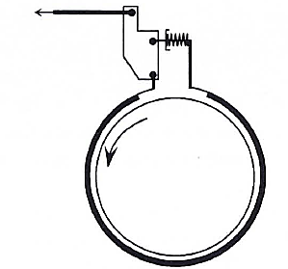
When the driver pressed the brake pedal a rod closed the band around the drum. This brought the friction lining into contact with the drum to slow the vehicle. This brake design featured servo-assistance, where the brakes naturally tried to increase the braking force. When the brakes were applied as the car travelled forward then the band actually tightened, improving the braking force; however when used in reverse it opposed application.
Improved braking performance and less likelihood of damage from road debris were the advantages of this system. However, as cars became faster this design did not develop enough force to stop cars. An added disadvantage was that when the brakes heated up, the drum expanded and contacted the band thus making the brakes drag.
The Drum Brake
This brake consists of a set of radially expanding shoes attached to a backing plate, which is connected to the suspension arms or differential housing. Surrounding the shoes is a drum connected to the axle. When the brakes are applied the shoes are forced outward to contact the drum, thus retarding the drum and the vehicle. The two shoes are termed leading and trailing shoes; the leading shoe is usually at the front during forward travel, with the trailing shoe being behind it. The shoes are lined with a friction material such as woven asbestos or pressed asbestos composite.
This design has many advantages over the contracting band brake. First, the shoes are enclosed in the drum so the friction lining is away from water and dirt, so they last longer. The drum brake also exhibits servo-assistance, in both forward and reverse; the leading shoe exhibits servo assistance during forward travel, the trailing shoe in reverse travel. Some front drum brakes use two leading shoes to improve braking efficiency.
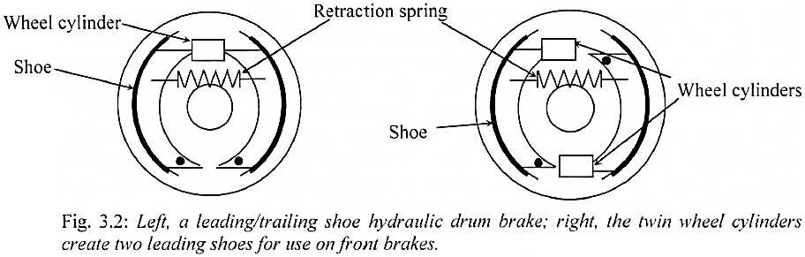
Initially drum brake shoes were opened by lever systems and a cam but as car speeds increased hydraulically operated pistons operated the shoes. This was achieved by using a hydraulic cylinder which was connected by piping to a master cylinder operated by the brake pedal. Hydraulic pressures were used to increase the braking force. This meant considerable saving on the cost of cable and rod systems.
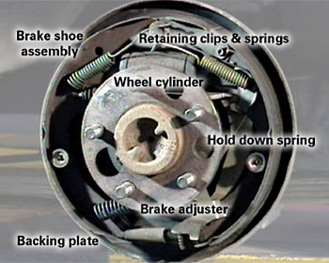
Figure: 1.3. Left, Hydraulic drum brake assembly. Right The brake drum fits over the brake assembly
In both cases the shoes are pulled away from the drum by retraction springs. Drum brakes may be adversely affected by water. As water is thrown onto the braking surface frictional resistance is reduced; hence braking is less efficient. The biggest disadvantage of the drum brake is poor heat dissipation. As the shoes are enclosed in the drum it is difficult to remove the heat energy produced, especially under continual application. As a result a new brake called the disc brake has replace he drum brake in nearly all applications. However the drum brake is still used as a rear brake for some cheaper cars and until recently was the only type of brake for use in trucks and buses.
Disc Brakes
The next major development in braking systems was the use of disc brakes. Although originally developed in the early 1900s, it was regarded as a ‘new invention’ at the London Motor Show in 1951. Previously disc brakes had only been used on motorcycles and aeroplanes but not motor cars. This development revolutionised the braking industry, so much so, that by the 1960s the use of disc brakes was widespread in British and European cars.
The disc brake is now the most common type of brake used in modern cars. It consists of a rotating disc (rotor) that is connected to the axle. Connected to the suspension is a backing plate with a calliper attached. The calliper wraps over the disc and houses two pads that are forced laterally against the disc by a hydraulically operated piston. The frictional resistance created retards the rotor. The disc brake offers better heat dissipation than the drum brake and also offers better wet-weather performance as water is thrown off the disc by centrifugal force.
Initially, the disc (rotor) was solid but now they have vents through them (ventilated discs) or they are drilled to further improve heat dissipation.
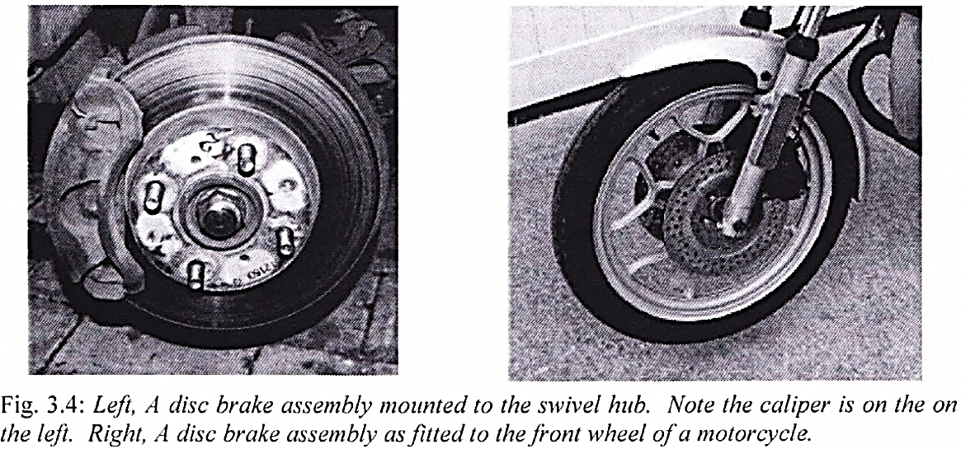
One disadvantage of disc brakes is that they have no natural servo-assistance, so the force at the pedal is very large. To reduce the effort the pedal force is "boosted". A vacuum booster, running off the engine manifold (or a vacuum pump in the case of diesels), achieves this. This magnifies the pedal effort the driver provides and improves stopping performance. Should a vacuum booster fail, then the effort needed to stop a disc brake car is very large.
Disc brakes also are not good as hand brakes due to the lack of servo-assistance, thus some cars use drums on the rear. PBR (a brake design and manufacture company) has developed a drum brake incorporated into the hub of the disc for use as a parking brake.
Brake Lining & Pads
Along with the development of brake mechanisms, frictional material for brake linings also developed. Early brake pad liners were made by weaving an asbestos yarn into the desired shape. Today the brake pad linings are produced from a combination of many materials.
Fibres, such as glass fibre, Kevlar, steel wool and carbon fibres; fillers, such as clay, calcium carbonate, barytes, fine metal and schist; binders, such as phenol formaldehyde; and friction modifiers, such as elastomers, brass and zinc, which are moulded into shape and cured.
Anti-lock Braking Systems (ABS)
Another major development in recent years is the anti-lock braking system, (ABS). This system prevents wheels from locking during emergency braking situations, enabling drivers to steer the vehicle while stopping.
When a car skids in dry conditions it stops quickly but not necessarily in a straight line. The unequal braking forces at the wheels cause a turning moment about the car's centre of rotation, which tends to cause the car to turn "off-line" or swerve. In the wet the wheels lock far more quickly and at a point way below maximum braking force. With a front wheel lock-up the car loses the ability to steer while a rear wheel lock-up often causes the tail to swing out. Both situations can lead to a loss of control and consequently accidents.
Car makers and brake designers have attempted to design braking systems that will not lock up. This is usually achieved by using three sensors and computer control over the braking circuit. When a wheel begins to lock up and slow down compared to other wheels, a wheel sensor mounted on the wheel will sense this. It will send a message to the computer to inform it of a wheel lock-up.
The computer will then release the hydraulic pressure at that brake calliper to allow the wheel to spin again. The brakes can then be reapplied and if the wheel locks again the procedure is repeated.

There is still concern about the performance of ABS brakes on gravel roads. Gravel roads need the wheels to lock and dig through the loose surface to the harder surface beneath, but as an ABS brake equipped car will not allow this to happen, an ABS equipped car will not stop as well on gravel.
Nowadays many cars with ABS also use the same sensors to control wheel spin under acceleration and cornering. Such traction control or dynamic stability control systems use the brakes operating independently to improve car's handling in challenging situations. Some off-road vehicles also use the ABS/traction system to ensure traction off road in-lieu of using differential locks.
Regenerative Braking Systems
Currently there is a trend in environmentally sensitive motor cars to replace a petrol or diesel engine with a hybrid combination of petrol or diesel and an electric generator. The principle is that the motor drives a generator that provides electricity to an electric motor. They also use batteries so in city areas the petrol or diesel motor does not need to run. The advantage of this means, it is also possible to use electricity to slow the car.
To stop the car the driver touches the brake pedal, causing the electric motor to act as a generator. The energy used to generate electricity develops a mechanical resistance, which helps to slow the car. At the same time the electricity produced is used to charge the batteries. This means that the car's kinetic energy is converted into useful electricity energy instead of being given off as heat energy.
These cars still have conventional brakes so that if the brake pedal is pushed further the conventional brakes come into operation. These systems offer a great deal of promise as they reduce the amount of wear on conventional brakes and also make use of the converted energy so such cars are more environmentally sound.
Automotive Hand Brake
Since the early development of the car, brakes weren't just used for stopping a moving vehicle; they were also used to hold a vehicle in a parked position. This parking feature is usually achieved using a hand brake. Most vehicles not sold in Australia use a hand operated brake that activates the rear brakes to stop the car from rolling. The hand brake uses a cable that connects the lever to the rear brakes. This means that the hand brake will operate in the event of a hydraulic failure in the main braking system; hence it also has a role as an emergency brake. But it must be used carefully as it is easy to make the rear wheels lock using the hand brake as weight transfers to the front wheels when decelerating.
Parking brakes used to be more effective with drum brakes due to the servo assistance of drums. But since most cars now have four wheel disc brakes, brake designers have managed to make the hand brake highly effective using today's disc brakes.
The following table will be supplemented with more specific historical perspective throughout the module, along with related developments in areas of materials and technology.
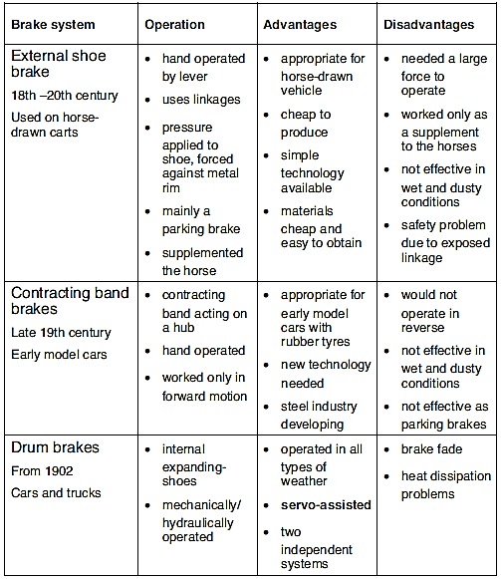

The Effect of Engineering Innovation
This section will look at the two main brake types (drum and disc), and assess what effect they have had.
Drum Brakes
- Improved stopping power means cars can travel faster while still stopping safely.
- The increased speed is a double-edged sword, because although cars now travel faster they are potentially less safe, as other systems such as suspension and steering need to be upgraded to deal with increased speeds.
- With the advent of drum brakes motor manufacturers started to fit four wheel brakes, thus making cars safer.
- The drum brake handles poor weather conditions better than the contracting band brake, so it is possible to use the car in rain and snow; previously that may have been dangerous.
Disc Brakes
- Cars are more effective at stopping at higher speeds.
- Improved heat dissipation over the drum brakes means safer continual braking effort (such as is required when descending a hill).
- Disc brakes provide improved braking in poor weather conditions.
- They are easily adapted to computer controls such as ABS.

Environmental Implications from the Use of Materials in Braking Systems
Of all materials used in braking systems, the asbestos formerly used in brake linings had the greatest impact on people. Prior to 1902 brake linings were leather or woven cotton, with poor thermal stability and low coefficient of friction, but in 1902 Herbert Frood developed woven asbestos lining. Asbestos gave the break lining greater stability at higher temperatures, thus the linings were more resistant to break “fade” (i.e. as the brakes become hot the frictional force available for breaking is reduced).
Although this new asbestos break lining was great for heat resistance, there were major health problems associated with its use. If the asbestos is broken into fibres it can be inhaled, lodge in the lungs and cause lung cancer. Of the greatest concern are the long “blue asbestos” fibres. As a consequence asbestos linings are not fitted to modern cars and in some countries totally banned. However, modern day materials such as aramid fibres and carbon still emit dust particles which are harmful to the environment.
Traditionally as brake pads were a mixed material they could not be recycled and therefore would end up as landfill. However modern day cast brake components and other metallic components can be sold as scrap metal. Today’s brake pads and shoes consist of a mixture of synthetic materials in addition to copper. Since 1998, the use of copper in automobile brake pads has increased nearly 90 percent. Most brake pads today contain about 15 to 30 percent copper.
- Recycling means less mining of material, which can lead to dust and waste gases such as sulfur dioxide which have harmful effects on the environment.
- Recycling saves landfill space.
- Recycling uses far less energy than that needed for manufacturing. This energy savings leads to the conservation of valuable reserves of oil, gas or coal and reduces the amount of CO₂ released into the atmosphere

- Name four devices in which brakes are used.
______________________________________________________________________________________________________________________________________________________

- Describe the drum braking system
____________________________________________________________________________________________________________________________________________________________________________________________________________________________________________________________________________________________________________

- Name the two developments, one in 1841, the other in 1888, which greatly affected the design of tyres and led to the subsequent demise of the externally applied shoe brake.
i 1841
ii 1888

- Describe the contracting band brake, a direct result of Dunlop’s patent.
____________________________________________________________________________________________________________________________________________________________________________________________________________________________________________________________________________________________________________

- List and discuss two reasons why the introduction of front wheel brakes was an important development.
____________________________________________________________________________________________________________________________________________________________________________________________________________________________________________________________________________________________________________

- What do the letters ABS stand for in braking systems?
___________________________________________________________________________

- Social and economic conditions have changed dramatically since the 1940s.
List some of the changes and describe the effect that the changes had on their lives. Make reference to the development of cars and in particular, the resulting development in braking systems.
______________________________________________________________________________________________________________________________________________________________________________________________________________________________________________________________________________________________________________________________________________________________________________________________________________________________________________________________________________________________________________________________________________________________________________________________________________________________________________________________________________________________________________________________________________________________________________

- Visit a variety of web sites then explain why ABS is used on heavy vehicles, how ABS works and their application to current model cars.
________________________________________________________________________________________________________________________________________________________________________________________________________________________________________________________________________________________________________________________________________________________________________________________________________________________________________________________________________________________________________________________________________________________________________________________________________________________
________________________________________________________________________________________________________________________________________________________________________________________________________________________________________________________________________________________________________________________________________________________________________________________________________________________________________________________________________________________________________________________________________________________________________________________________________________________
________________________________________________________________________________________________________________________________________________________________________________________________________________________________________________________________________________________________________________________________________________________________________________________________________________________________________________________________________________________________________________________________________________________________________________________________________________________

Engineering Mechanics & Hydraulics

Friction
When you walk on a rough surface, such as a footpath, then try to walk on an ice rink there are two very different results.
To be able to walk on a rough surface such as the footpath, friction is used to allow you to make progress. To walk on an ice rink, where there is little or no friction, is almost impossible. Friction allows you to walk, the lack of friction allows you to ice-skate, but not to walk on ice.
Friction is the resistance to motion that occurs when two bearing surfaces slide, or tend to slide, over each other.
- Place your right index finger, against the palm of your left hand.
- Very lightly push your finger across your palm.
- Repeat, but slightly increase the downward force.
- Now really increase the downward force and try moving your finger.
Did you notice that as you increased the downward force, that the friction force increased? Did you also notice that your hand got hotter as the force increased? Were you able to apply a big enough downward force that prevented you moving your finger across your palm? Your palm has just applied a braking force to your finger.
Repeat the activity, pushing your finger against various surfaces such as your desk top, a book cover, laptop and an eraser.
Did you notice that the same results occurred as before? Did you also notice that the frictional resistance was different for the different materials used in the activity? Were you again able to apply a braking force? Did the braking force vary with the different material?
Now you will see how these activities apply to friction forces.
A friction force is the reactive force opposing the movement of two touching surfaces. The friction force varies directly with the applied force that pushes the bearing surfaces together and therefore with the normal reaction.
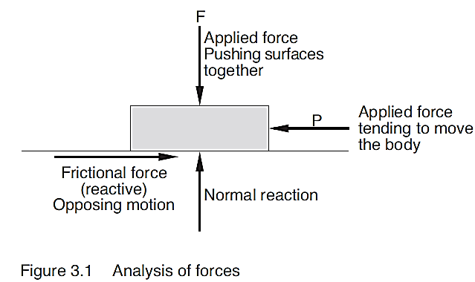
Friction Forces in Braking Systems
Friction forces occur in braking systems due to the reaction between the specially compounded materials of the brake linings/pads, and the cast iron or aluminium alloy metals of the brake drums/discs.

How Brakes Work
Brakes are able to slow or stop a moving vehicle by retarding the rotation of the wheels through developing a ‘controlled’ friction that converts kinetic energy of the vehicle into heat (energy). The heat energy is then dissipated into the surrounding air through the brake drums or brake discs.
When brakes are applied a combination of the velocity of the vehicle and mass of the vehicle determine the amount of kinetic energy that must be converted to heat energy. However, it is actually the rolling friction between the tyres and the road surface that eventually brings the vehicle to a stop.
Coefficient of Friction
Coefficient of friction µ (Mu) is the ratio of the limiting frictional resistance to the normal reaction. The coefficient of friction is a constant for any two materials in contact.
The frictional force is dependent on the coefficient of friction between the mating surfaces and the normal reaction force. The lower the coefficient of friction, the higher the normal reaction must be to gain the same level of frictional resistance or vice versa.
The coefficient of friction between different surfaces varies, as Table 3.1 shows. This table gives the approximate coefficient of friction between the listed surfaces. Note that we are talking about static friction here as opposed to kinetic friction. When dealing with static friction the frictional force always has an equal magnitude to the force tending to cause motion. However, once the object starts moving the kinetic frictional force falls to a lower value than the static frictional force. Thus the coefficient of friction for surfaces is different depending on whether an object is moving or not. This is why it is easier to slide a heavy object once it is moving; the hardest part is moving it initially.
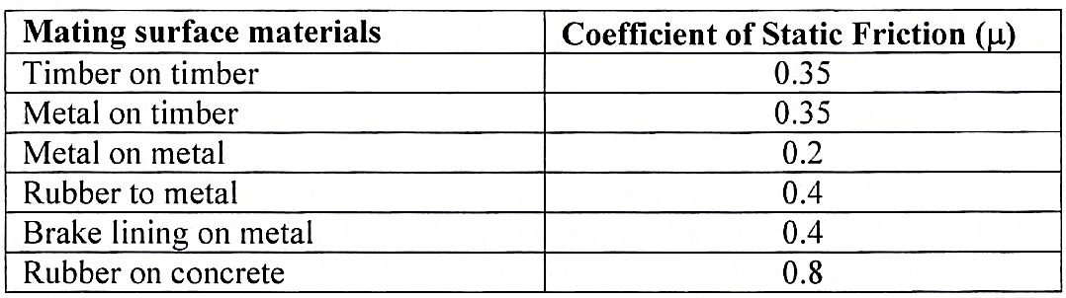
Some materials, which have a high coefficient of friction, may not be suitable for some braking applications. For example most bicycles still use a composite rubber block acting on the rim. This is suitable for a bike, but not for cars, due to the high stopping force and heat generated in automobile braking systems. The friction material used in disc and drum brakes may have a lower coefficient of friction than the bike brake block, so a greater force must be applied to attain the required frictional force. However, these materials deal far better with the high temperature in automotive brakes.
Coefficient of Friction in Braking Materials
If the coefficient of friction between the materials of the brake liners/pads and the materials of the brake drums/discs is excessive, the abrasion would quickly wear down both the liners/pads and the drums/discs. A high coefficient would also cause the brakes to lock. Brake materials are therefore manufactured with a range of coefficients from low friction, 0.25–0.3 through to high friction, 0.4–0.45.
Analysis of Friction Problems
Friction Force
Friction force is a reaction or a reactive force that opposes motion or pending motion that occurs due to an applied force.
Force Analysis
Analysis should commence with the determination of the direction of the friction force. The friction force should then be drawn on the force analysis diagram. All other forces acting on the body should then be drawn on the analysis diagram. These forces should then be drawn as a freebody diagram that shows only the previously analysed forces.
Note the friction force always opposes motion or pending motion.
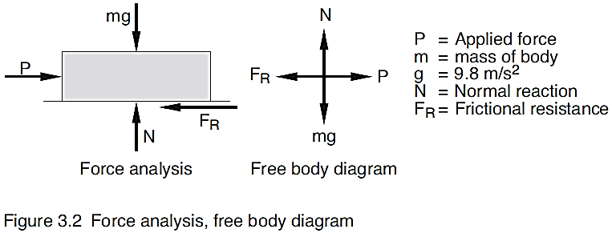
Solve, using the linear equilibrium equations;
Two important formulae which must be known.
Limiting friction is the frictional resistance acting when a body is on the point of moving.
Coefficient of Friction µ (Mu) and friction formula
Coefficient of friction µ (Mu) is the ratio of the limiting frictional resistance to the normal reaction.
Alternative method of writing formula
Note: this formula only applies when limiting friction is involved.
Worked example
In the following examples different forces are being applied to a body on a horizontal plane.
The problem is usually described in words accompanied by a space diagram. The diagram is used for the analysis of the problem and will be referred to as an analysis diagram.
To solve the problem:
- Analysis diagram: The analysis diagram is used to determine and show all of the forces acting on the body. As the friction force opposes motion or pending motion, the first step must be to determine and show the friction force on the analysis diagram. Having shown the friction force, show all of the other forces acting on the body. Remember that if the body is to be in equilibrium the two linear equilibrium equations, Σ_{H} = 0, Σ_{V} = 0, must be satisfied.
- Free body diagram: The free body diagram is used to show only the forces acting on the system. It is easier for analysis if the forces are drawn with the arrows pointing away from the point of intersection as shown in the solutions. This method uses the principle of transmissibility, and thus does not alter the question.
- Equation for FR: Write an equilibrium equation for FR using the two linear equilibrium equations, Σ_{H} = 0, Σ_{V} = 0 and F =µN.
Note: the friction force always opposes motion or pending motion.
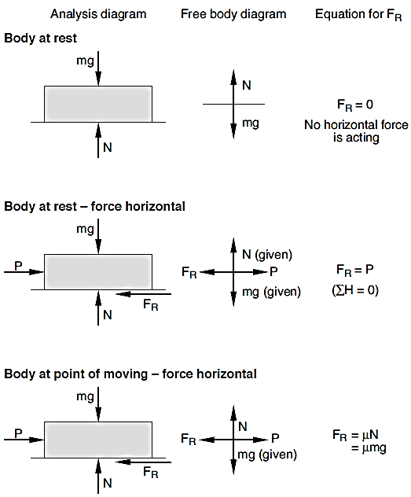

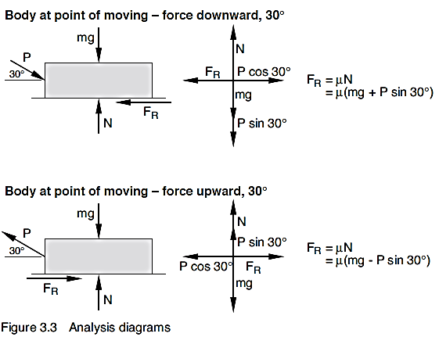
An alternative method, the angle of friction
Angle of friction φ, (phi) also only applies to limiting friction.
If the friction force and normal reaction are replaced by a resultant force, R, the angle that R makes with the normal is φ, the angle of friction, and tan φ = µ.

To solve the problem:
- Analysis diagram: The analysis diagram is again used to determine and show all of the forces acting on the body. The first step is to determine and show the friction force on the analysis diagram and then show all of the other forces acting on the body.
- Angle of friction method: Replace the friction force and normal reaction with a resultant force, R. Indicate the angle that R makes with the normal as φ, the angle of friction
- Free body diagram: On the free body diagram show the three forces acting on the system, mg, P and the resultant force R.
The solution is now found using a force diagram. You solve the problem using a graphical method or using trigonometry.
Once you learn this method of analysis you will find it much easier and quicker to use than the previous method when solving limiting friction problems.
Sample solution
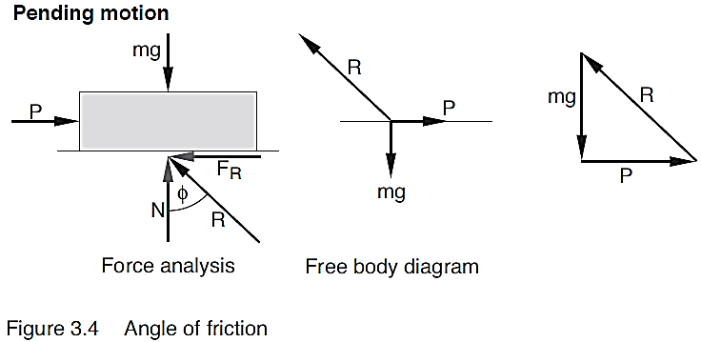
The solution using a force triangle as shown is a much quicker method.
Worked example
Repeat the force analysis for parts iii, iv and v, using the angle of friction method.
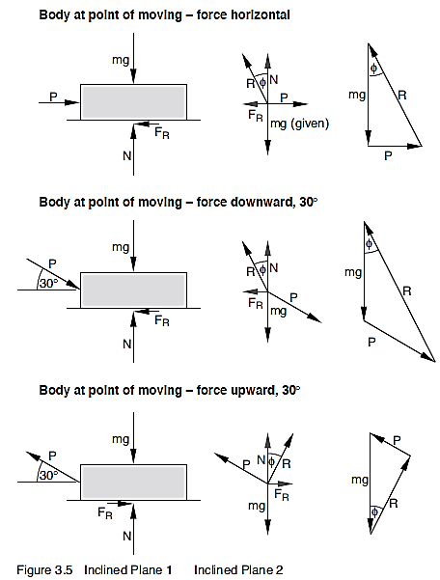
Friction on an Inclined Plane
Limiting friction on an inclined plane
When a body is at rest on an inclined plane, and is on the point of moving, (ie pending motion), the angle of inclination, θ, is equal to the angle of friction, φ, and tan φ = µ.
tan φ = µ
This angle, θ, is sometimes called the angle of repose.
θ = φ, and tan φ = µ
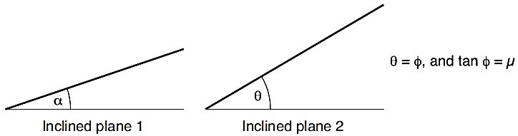
Figure 3.6 Inclined planes
A body at rest on Plane 1 is in equilibrium. The friction force is equal in magnitude, but opposite in sense to the weight component down the plane.
A body on Plane 2 is on the point of slipping (that is, pending motion). Again the friction force is equal in magnitude, but opposite in sense to the weight component down the plane. As it is on the point of moving, (that is, pending motion), the angle of inclination, θ, is equal to the angle of friction, φ, and tan φ = µ.
- The coefficient of friction (µ) is the ration between what two values?
__________________________________________________________________________________________________________________________________________

- A 20 kg box resting on a surface has a horizontal force, P, applied to it. Determine the value of P that will put the box to the point of sliding (µ=0.4).
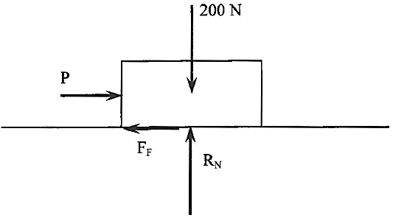

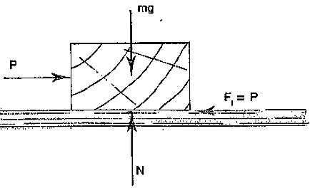
- A 25 kg block of wood rests on a wooden floor. If the coefficient of friction is 0·4 find the maximum horizontal force which can be applied before the block will move.

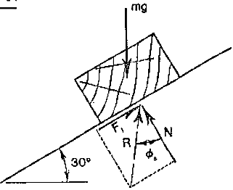
- The angle of inclination of a plane is increased until the friction between the plane and a wooden block resting on it is limiting; at this instant the plane is inclined at 30° to the horizontal. Determine the coefficient of static friction between the mating surfaces.
Note: Øs = 0 at the point of limiting friction.

A 95kg crate of airship parts needs to be loaded onto a truck. Determine the force (F) in the rope required to move the crate up the ramp if μ = 0.25. 08
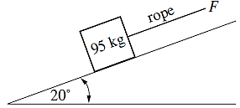

- The braking force applied to each brake pad from the calliper is 3 kN as shown. The coefficient of friction is 0.4. What torque (moment) is required to overcome the braking force and allow a stationary vehicle to start moving?
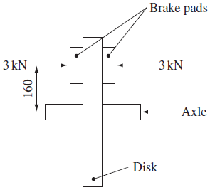

- If the front wheel of a car provides a braking force F_{B} at the road, and the coefficient of friction between the disc and pads is 0.45, what will be the value of F_{B} when the disc brake pads are forced against the disc by a 1.5 kN force?
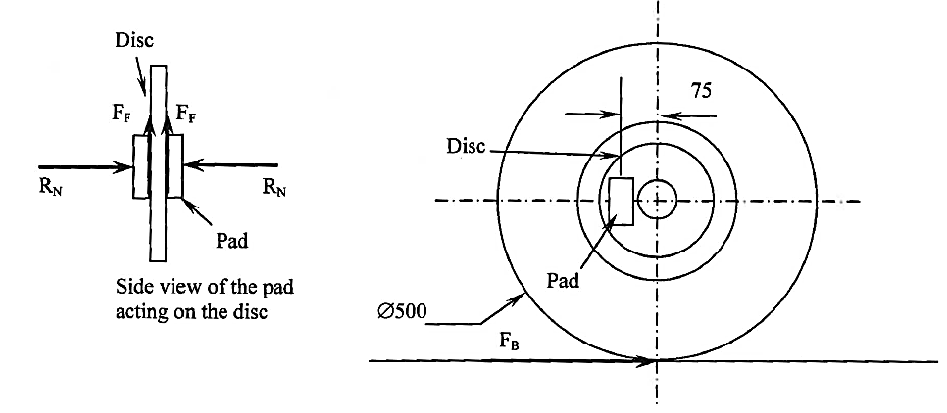

Friction Prac
Method 1
Determine the horizontal force required to move the body across a surface. You may be able to secure a spring balance to the body. Alternately you could use a fixed pulley and attached masses. Now, using the friction formula F = µN determine the coefficient of friction.
Figure 3.7 Coefficient of friction on a horizontal plane
Method 2
Place the body on an inclined plane. Determine the angle of repose of the inclined plane, that is, the angle of inclination of the plane when the body just commences to move. Now, determine the coefficient of friction knowing that the angle of inclination, θ, is equal to the angle of friction, φ, and tan φ = µ.
Figure 3.8 Determining the angle of limiting friction
Exercise
Determine the coefficient of friction between two materials and write a 1/2 page report on the experiment and state your conclusions.

Load-Extension and Stress/Strain Diagram
Load/extension diagrams are a type of graph that displays the relationship between load and extension. Load is plotted on the vertical axis, while extension is on the horizontal axis. The load/extension graph is usually converted into a stress/strain diagram to give a graph that is more easily compared with similar tests for other materials. Both of these graphs will have the same general shape and each display various features that are of importance.
When a tensile test is conducted, a graph is produced during the test, plotting load on the vertical axis and extension on the horizontal axis.
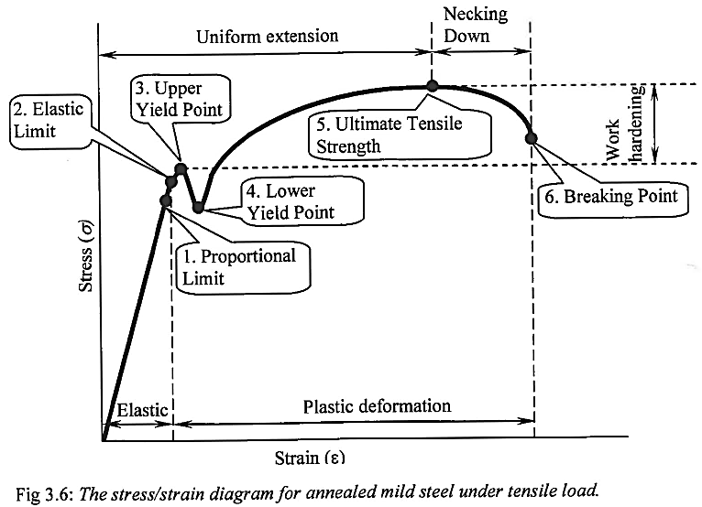
The following features are important and are displayed on the stress/strain curve:
- Proportional limit: Up to this point the curve displays a proportional (straight-line) relationship between stress and strain (this is known as Hooke's Law).
- Elastic Limit: Up to this point the strain is elastic, thus if the load is removed the object will return to its original shape and size. Beyond this point permanent deformation occurs.
- & 4. Yield points: These points show a marked increase in strain without an increase in stress. They may be likened to the material momentarily "giving up" due to slip and dislocation movement.
- Ultimate Tensile Strength: This is the maximum stress that the material can withstand. It is of little concern as structures are designed to never exceed the elastic limit, but it is of concern for press forming operations to ensure the material does not fracture during forming.
- Breaking Point: At this point the material will break or fracture.
Other features on the diagram are:
- Elastic region: In this region all strain (or deformation) is elastic and removal of the deforming load will mean a return to its original dimensions.
- Plastic region: In this region deformation is permanent and removal of the force will not mean a return to its original dimensions.
- Uniform extension: This part of the graph shows that the material is undergoing uniform extension. That is, it is stretching an even amount along its length.
- Necking: In this area the test piece will, all of a sudden, undergo localised deformation. A part will deform while the rest stays as it was.
- Work Hardening: In this region slip and dislocation movement results in the material gaining increased strength and hardness with reduced ductility.
- Toughness: The area under the whole curve represents a measure of toughness, which is the material's resistance to shock loading. The greater the area under the curve, the greater the toughness of a material.
- Resilience: The area under the curve in the elastic deformation region represents the resilience of a material. The resilience is the amount of strain energy that is stored in the deformed object.
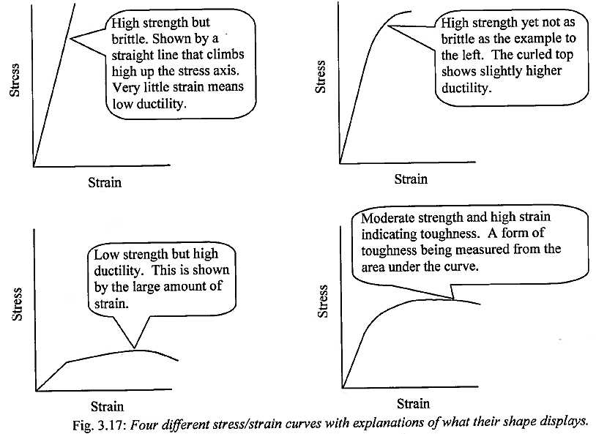

Virtual Activity
Task 1: Explore the virtual excursion Virtual tensometer to develop an appreciation of a tensile test and the procedure for performing tensile tests. Work through information, clips and activities. http://lrrpublic.cli.det.nsw.edu.au/lrrSecure/Sites/Web/tensile_testing/

Task 2: Students to determine and verify the formulas for stress and strain used to calculate values in the stress/stain spread sheet. The Engineering studies formula sheet link to the Board of Studies website reinforces the process of calculation of stress and stain values.

Task 3: Complete the applet multiple choice Tension & Compression Testing quiz located on the student server at:
D:\users\nathan.koen\AppData\Local\Temp\Temp3_Tensile Strength.zip\applets\tension_and_compression_quiz\tension and compression quiz.htm

Stress & Strain
Stress and Strain relates to what happens to a material when it is subjected to a load. They are often confused with one another. When a material is subjected to a tensile load then it will stretch in length. If it stretches it must reduce in size laterally as its volume must remain constant. Likewise it is useful to know the load that produces a given extension. But it is more useful to relate the load to the original shape of the specimen. This is known as stress.
When a force is applied to an object, if it doesn’t move, then there must be some force opposing it.
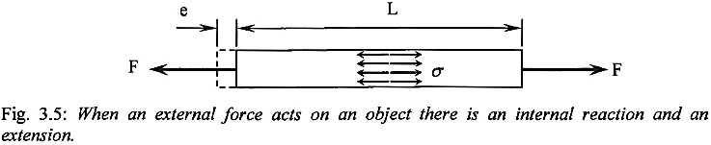
What is happening to the object? It’s under stress.
An engineer must be aware of these stresses as they could cause the structure to deform and subsequently collapse.
Hooke’s Law
Robert Hooke, in 1662, as the Curator of the Royal Society, demonstrated, using the tensile loading of a piece of wire that extension was proportional to the applied load – Hooke’s Law. His contribution to the study of the strength of materials and the resulting effect on the design of components was enormous.
Young’s Modulus
Thomas Young, in 1807, showed that Hooke’s Law was only effective up to a certain limit. It was a characteristic of the material and applied equally to the compression of a body as well as to tension. His name is given to the Modulus of Elasticity, or Young’s Modulus.
When a body has a load or force applied to it, some deformation, either extension or contraction will occur. Depending upon the size of the load and the mechanical strength of the body, the deformation will be either elastic or plastic.
Elastic Deformation
Elastic deformation means that the body will return to its original shape and size when the deforming force is removed.
Plastic Deformation
Plastic deformation means that the body will not return to its original shape and size when the deforming force is removed. The body is said to have taken a permanent set.
In both of the above cases, when the deforming force is being applied, an internal resistance is tending to prevent the body from deforming. This internal resistance to deformation is called stress.

Stress
Stress is a body’s internal resistance to an externally applied force that tends to deform the body. It may be tensile, compressive or shear, depending upon the applied load. This internal reaction is related to the original cross sectional area to quantify the nature of the reaction.
Calculation
Stress is calculated as load per unit area.

Formula
Stress =
σ =
Symbol: σ (sigma)
Units
Pascals, (Pa). Other permitted units include:
kilo Pascal: kPa, 103 Pa | Mega Pascal: MPa, 106 Pa | Giga Pascal: GPa, 109 Pa
Note: you must always convert to basic units when doing calculations.
Basic units:
Load = newtons (N) | Area = square metres (m²) | Stress = Pascals (Pa)

Types of Stress
Tensile stress occurs when the externally applied load tends to stretch the body.
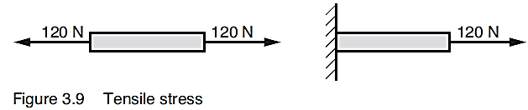
Compressive stress occurs when the externally applied load tends to shorten the body.
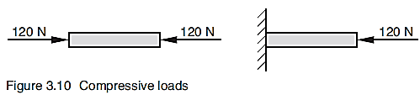
Shear stress occurs when the externally applied load tends to slide one part of the body across another part of the body.
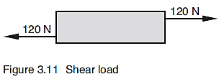
Problem solving
There is only one very simple formula to learn, but it takes much practice to be able to analyse and solve problems. (See examples 1 & 2 below).
Area being stressed
The area being stressed varies with the different application of the load. In tensile and compressive loads the area being stressed is usually the cross sectional area. In shear loads, the area being stressed is the shear area that is the area that would have to break if the component were to fail under the applied load.
Method
All problems should be set out and presented as follows.
i Summarise the given data, using the related symbols from the formula, and the given units.
ii Convert all units to basic units where appropriate.
iii Determine the area under stress. It sometimes helps to use a sketch of this area.
iv Select and write the appropriate formula.
v Substitute the data into the formula, ensuring that you use the basic units.
vi Complete the necessary calculations.
vii Write the solution to the problem using correct engineering units.
Worked example 1
A cylindrical braking rod of mild steel, diameter 12mm, is subjected to a tensile force of 5kN. Determine the tensile stress in the rod
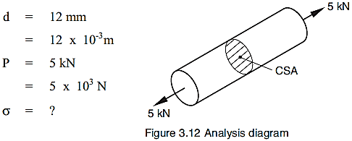
Area being stressed is the cross sectional area (CSA).
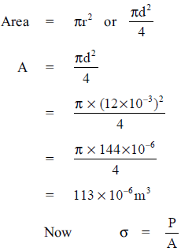
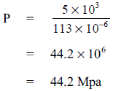
It should be noted that in most cases of stress analysis the cross sectional area will be given in mm or calculated in mm². It is important to ensure that values are converted into correct metric base units so that correct derivations result. If you divide a force in Newtons by mm² your answer will be in MPa, not Pa. While this may seem a shortcut it can present problems later when using stress with other values if care with units is not observed.
Worked example 2
A cylindrical punch, of diameter 8 mm is used to punch out the holes of a brake liner of thickness 5 mm.
- If, during the punching operation, the compressive stress in the punch is 120MPa, determine the force used to punch out the hole.
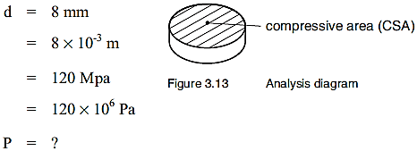
Area being stressed is the cross sectional area.
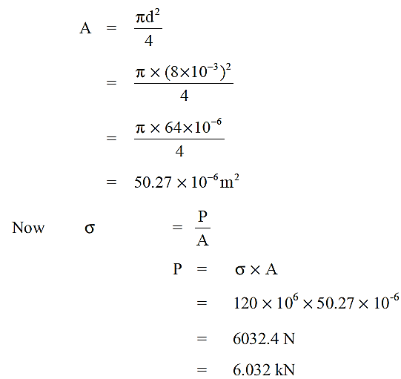
- Using the previous data as well as the calculated force in the punch from part i, determine the shear stress in the lining material. Area being sheared is the curved surface area of the cylindrical shape being punched out of the liner.
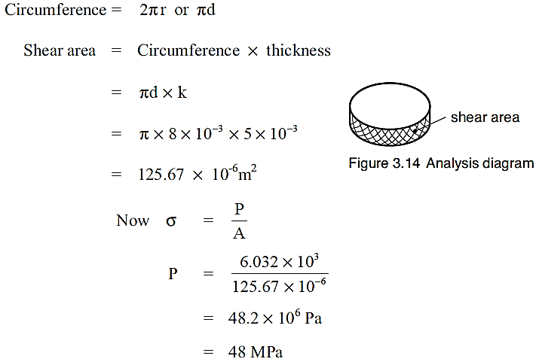
You can see from these two worked examples that it is very important to analyse each question. It is especially important to determine the area being stressed, so that errors do not occur.

Strain
Strain is the proportional change in length caused when a specimen is under an axial load. Strain is the ratio of the change in length of a body with respect to its original length. It is calculated as deformation per unit length.
Formula
Strain =
ε = e/L
Symbol: ε (eta)
Worked example 3:
Find the strain of a brake rod if it is compressed 0.3mm when it is 70mm long.
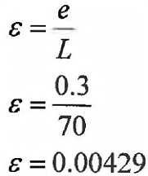
Therefore the compressive strain is 0.00429 or 0.429%.
Worked example 4
If a cable in a braking system has a tensile load placed on it and it has a strain of 0.003, and the length is 1.2m, what is the extension?
To solve this we must make e the subject of the equation.
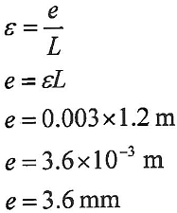
The brake cable will extend 3.6 mm (note the unit change).
Strain is dependent on the load applied and how much the object compresses or stretches.
Units
Strain is a ratio. It is sometimes expressed as a percentage; an example is percentage elongation, that is, strain expressed as a percentage.
Now we will consider the contribution of Robert Hooke and Thomas Young to the scientific design of engineering structures.
The ratio of stress to strain, within the elastic limit is a constant for a given material. It is a measure of the elasticity or stiffness of the body.
Formula
Modulas of Elasticity | =
E | = |  | (within the elastic limit)

Derived formula
E | =
Units: Pascals (Pa), and engineering multiples; kPa, MPa and GPa.
Worked example 5
A mass of 1.2 tonne is suspended from a 12m length of fencing wire during an experiment to confirm Hooke’s Law. If the modulus of elasticity of the mild steel wire is 210GPa, and the diameter of the wire is 5mm, determine the extension of the wire.
Note in this example mass is given as 1.2 tonne. This must be converted to basic units, kg’s, by multiplying by 10³, and then to the weight force, in Newtons, by multiplying by 10.
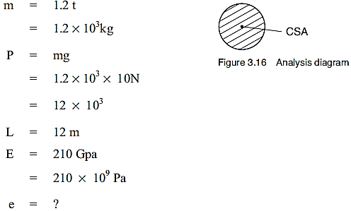
Area being stressed is the cross sectional area.
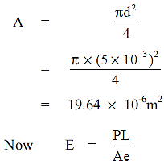
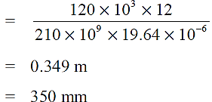

- A tensile test sample fails at a load of 15kN. The original cross-sectional area of the sample was 19.6mm² and the cross-sectional area at fracture is 15.2mm²
Determine the engineering stress.

- The typewriter's body is made from sheet metal 1.5mm thick, with a shear strength of 350MPa. Calculate the force required to punch a Ø10 hole in the body of the typewriter.

Force = ...................................Kn

- A steel specimen of gauge length 56 mm and cross sectional area 100 mm² has a tensile load of 1kN applied to it. If E = 206 X 10⁹ Pa, determine the extension and the strain in the specimen.

- A rod in a machine compresses from 250 mm to 249 mm during the operation of the machine. Determine the strain in the rod.

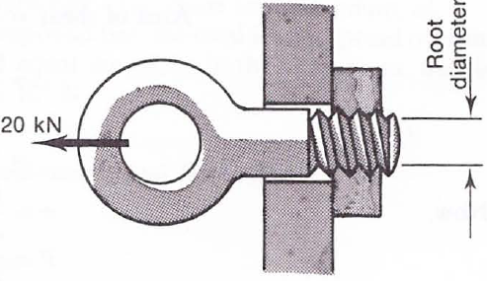
- An anchor bolt has a 20kN tensile load applied to it as shown. Determine the minimum root diameter of the bolt if the allowable working stress is 140MPa.
Analysis: The area over which tensile stresses will act is the root area of the thread where d = the root diameter of the bolt.

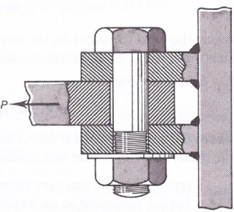
- A 30mm bolt holding three plates together in a machine is loaded in double shear as shown. Given that the factor of safety is 3, calculate the maximum value of the force P if the allowable shear stress in the bolt is 50MPa.

Work, Power, Energy
Work
Work in the engineering sense differs from the general use of the term. Work in engineering occurs when a force causes motion, which may either be a car travelling down a road or deformation caused by a tensile or compressive load. Thus work is done when a force causes a car to move down a road, and it is also done when we squeeze a brick in the wall of a house or compress a pin in a braking system. If no motion/deformation occurs then no work is done.
Mechanical Work
Mechanical work is done when a force acts upon a body and produces a displacement.
The work done by a force is determined by the product of the force and the displacement of the point of application of that force.
Work | = | Force (N) x Displacement (m)
W | = | Fs
Units of work: Joule, J.
The unit for work is the Joule (J); one Joule is equivalent to one Newton moved one metre. Since force and displacement are vector quantities, so is work. As a vector there can be negative and positive work; positive work occurs when work is done in the direction of the applied forces, and negative work occurs when the work is done in the opposite direction to the applied force.
Work Done by a Force against a Resistance
Applied forces are forces that may for example cause acceleration or deceleration. Acceleration forces do positive work while decelerating forces do negative work. Applied forces also include tensile, compressive or shear forces; these tend to cause deformation (a form of motion) in objects.
Frictional Resistance: When a body, on an horizontal plane, moves with uniform velocity, a distance, s, against a frictional resistance, the work done by the applied force in overcoming this resistance is:
 | Work | = | Frictional resistance x Displacement
 | W | = | F_{R} x s
Gravity: When the centre of mass of a body is raised through a vertical distance (h), the work done against gravity is:
 | Work | = | Mass x Acceleration due to gravity x Height
 |  | = | mgh
Inclined plane (no friction): When a body on an inclined plane of angle θ to the horizontal, is moved at uniform velocity a distance (s), up the incline, by a force applied parallel to the plane, the work done is:
Work = mg sin θ × s
But sin θ =
=
W = mgh

Energy
Energy as a concept is closely related to work. Energy may be defined as an object's ability to do work. Energy can exist in many forms, for example mechanical, chemical, electrical, heat and atomic. We are primarily concerned with mechanical, kinetic and potential energy.
Mechanical energy is a body’s capacity to do work. A body that has a capacity to do work is said to possess energy; the amount of energy is determined by the quantity of work it can do. Units are therefore the same as for work, Joule, J.
Kinetic energy (KE) is the energy a body possesses due to its motion. It is determined by the amount of work done in bringing the body to rest.
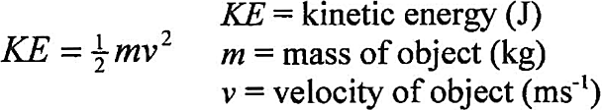
Potential energy (PE) is the energy an object possesses due to its position. It is determined by the amount of work done in lifting the body through a vertical height. If an object is raised to a height h above a fixed reference point (usually the Earth) then the potential energy is a measure of the object's ability to do work due to that position.
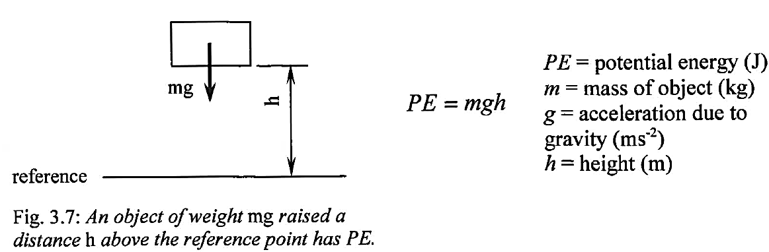
Types of Energy in Braking Systems
Heat energy: When any vehicle, be it a car, truck or bicycle, is travelling along it possesses kinetic energy. If that vehicle has friction brakes, and they are applied, then that kinetic energy cannot be destroyed, it must be converted to another form. Some of the energy is used to retard the vehicle, and the remainder of the energy is converted to heat and perhaps sound. For friction brakes the removal of heat energy is very important for if the brakes get too hot they may lose their effectiveness.
Electrical energy: The friction brake is a particularly wasteful way of slowing a vehicle, so some trains and newer cars are using electrical regeneration as a form of braking. In the case of hybrid cars (cars with a petrol or diesel motor producing electricity via a generator to drive the car), the electric motors at the wheel are operated to act as generators, thus producing electrical energy and feeding it back into the batteries. This electricity production retards the car; thus the kinetic energy is converted into electrical energy and then chemical energy (stored in the battery).
Conservation of Mechanical Energy
When considering the vertical movement of a body.
Loss of PE = Gain in KE and conversely Loss of KE = Gain in PE
Work and energy are very important to engineers when designing cars and braking systems. More importantly it is the rate at which a car or brake can do the work or transfer energy. Since energy is conserved, that is converted from one form to another. When solving questions using mechanical energy we can summarise it as follows: Any PE present plus any KE present will equal the final KE and PE unless there is work done.
Mathematically we can express this principle as follows:
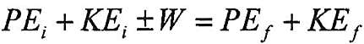
Fully expanded it is as follows:
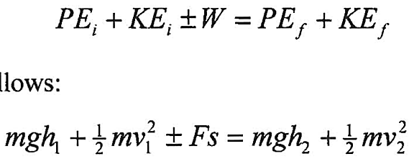
So in any mechanical energy problem ascertain the PE and KE initial, factor in any positive or negative work, and then you can determine the final energy at the end.

Power
Power is the time rate of doing work, and is determined by the ratio of the work done over time taken to do the work. The unit for power is the watt (W) and is one joule per second. Power is useful when it comes to comparing the amount of work done by machines in a given time. For example, if two people go up the same flight of steps, both have done an equal amount of work, but if one person does it in 5 seconds while the other person does it in 10 seconds, then the quicker person has used double the power of the slower person.
Power =
P =
Derived from this formula are two very important formulas.
P = but W = Fs
∴ P = and = v (velocity)
∴ P = Fv
P = = = Fv
Units of Power: Watt (W)
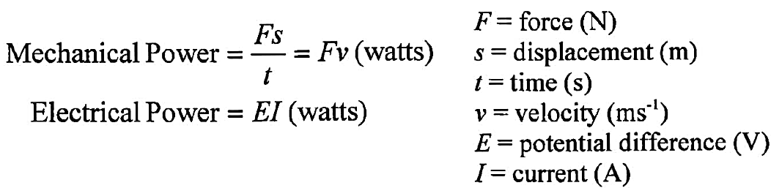
Power in Braking Systems
Consider two cars of equal mass, both travelling at 100 km/h and both coming to rest using only the brakes at full effort. If car A takes 20 seconds to stop while car B takes 30 seconds, then car A has a greater braking power than car B.

- Define the term ‘mechanical work’.
_______________________________________________________________________________________________________________________________________________________________________________________________________________

- Analyse each of the following three problems, and determine an equation for the work done in moving the car.
- A car travelling at constant velocity on a horizontal plane, against a frictional resistance (F_{R}) a distance (s).
Work done in overcoming this resistance is: ____________________________________
- Against gravity when raising a car of mass (m), through a height (h):
Work done against gravity is: _______________________________________________
- A car travelling at constant velocity, up an inclined plane of angle θ to the horizontal, through a distance (s).
Work done is: ____________________________________________________________

- Determine the work done by a braking system in the following. In each case the hand brake is in operation, but in ‘c’ ineffectively.
- Car stationary on a horizontal surface.
Work done by the hand brake = ______________________________________________
- Car stationary on an inclined surface.
Work done by the hand brake = ______________________________________________
- Car on an inclined surface, moving downward at constant velocity.
Work done by the hand brake = ______________________________________________

- Define the following types of energy and also give the formula for each.
Kinetic energy:
____________________________________________________________________________________________________________________________________________________________________________________________________________________________________________________________________________________
Potential energy:
____________________________________________________________________________________________________________________________________________________________________________________________________________________________________________________________________________________

- Define the term ‘power’ when referring to mechanics and also write the formula.
____________________________________________________________________________________________________________________________________________________________________________________________________________________________________________________________________________________

- Two very important formulas may be derived from the, power equals work divided by time. Show how

Fluid Mechanics
Fluids differ from solids in that they cannot support shear stresses; they deform to take the shape of any container. Thus the way a fluid interacts with its surroundings is vastly different to the way a solid reacts.
Basic Hydraulic Braking Systems
Originally, car brakes were operated by mechanical means using levers, cables and rods as linkages. These braking systems were unreliable, causing many service problems in maintaining linkages and providing equalisation of braking pressure to the brakes.
Hydraulic systems were developed based on the simple principle that pressure exerted at any point on a confined fluid will be transmitted throughout the fluid equally and undiminished in all directions.
Liquid flows freely, assumes the shape of the container, cannot be appreciably compressed, and, if contained in a sealed system, allows pressure to be equally and evenly distributed throughout the system. The hydraulic-brake actuating system thus provides equalised transfer of pressure from the applied force, through the system, to the brake shoes or discs.
The advantages of this basic hydraulic system over the original mechanical brakes are that it gave completely uniform pressure throughout, greatly reduced adjustment problems, and provided even braking on all wheels at all times. Later developments of front brakes and ABS braking systems modified the last ‘advantage’.

Pascal’s Principle
Pascal’s Principle states that if the pressure at any point in a liquid that is enclosed and at rest, is changed, then the pressure at all points in the liquid changes by the same amount.
Thus when a fluid completely fills a sealed container, or connected containers, and pressure is applied by means of a cylinder and piston, that pressure is transmitted equally throughout the whole of the enclosed fluid.
If pressure is applied to a liquid in a sealed container or system, through the application of a force (F₁) in a cylinder of cross sectional area (A₁), an equal pressure will be transmitted to a larger piston and cylinder, of area (A₂), causing a thrust or force in this piston, of magnitude F₂.
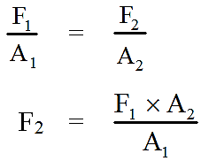
If A₂ is very large compared to A₁ a comparatively smaller force applied to the smaller piston can overcome a large resistance acting on the larger piston. Additionally, this can apply to a number of different cylinders and pistons attached to the sealed system.
Braking Systems
This principle forms the basis of hydraulic machines, including the hydraulic press, hoist, jack and hydraulic braking systems.
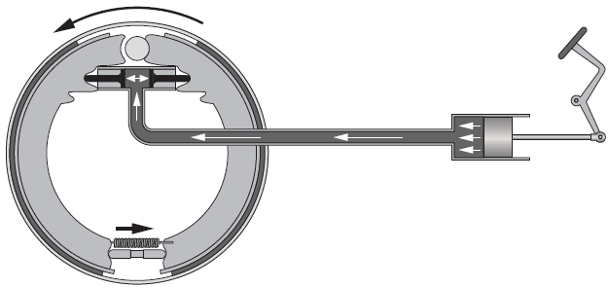
Figure 4.3 Hydraulic Braking System
Worked example
Figure 4.4 represents a sealed hydraulic braking system. A force of 100 N is applied to the brake pedal as shown. Size details of the pedal, master cylinder, and front and back wheel cylinders are given on the diagram.
Determine the thrust (force) delivered by each of the wheel cylinders.
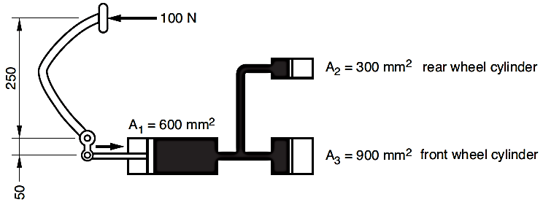
Figure 4.4 Hydraulic braking system
Solution
The solution is based on Pascal’s Principle, that any pressure applied to a liquid in a confined container or system is transmitted equally and undiminished to all parts of the container or system.
i Determine by moments the resultant force on the master cylinder caused by the applied force of 100 N exerted on the brake pedal.
∑M about pivot: 100 x 250 = 50 × R = 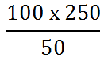
Resultant force on master cylinder = 500 N
Note: the lever system has provided a mechanical advantage of 5!
ii Determine the pressure generated in the system by this resultant force.
Pressure generated at master cylinder = Force/area
P =
=
= 833 kPa
iii Determine the thrust at the rear wheel cylinder.
Since the pressure of 833 kPa is equal in all directions
Force exerted by the piston = pressure x area
= 833 × 103 x 300 × 10-6
= 250 N
iv Determine the thrust at the front wheel cylinder.
Since the pressure of 833 kPa is equal in all directions,
Force exerted by the piston = pressure x area
= 833 × 103 × 900 × 10-6
= 750 N
Application to braking systems
By varying the diameter of the cylinders it is possible to distribute the pressure as needed. This is particularly applicable to the different stopping forces needed at the front and back wheels.
When the brakes are applies the reaction at the front wheels is greatly increased due to the tendency of the vehicle to continue its forward motion. The front brakes therefore need a greater applied force than the rear wheels. One way that this can be done is by using larger wheel cylinders on the front brakes.

Hydrostatic Pressure
Principle 1
The pressure at any point in a static fluid is the same in all directions.
When unbalanced pressures are exerted on the molecules of a fluid, the fluid will flow. If the fluid is at rest, then an equal pressure acts in all directions at any point in the fluid.
Principle 2
If an object is placed into a fluid then the fluid pressure will act upon the entire surface of the object at right angles to the surface. The pressure may be defined as the force per unit area, thus:
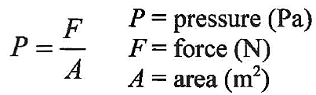
When a fluid flows it exhibits viscosity or a resistance to flow. This is due to the shear forces parallel to the wall. If the liquid is at rest, the molecules are free to slide over each other, so the only reaction forces are perpendicular to the walls.
The cross sectional size or shape of a container does not affect hydrostatic pressure, but the depth affects it. The deeper something is under a fluid the greater the pressure, for example the deeper a diver is the greater the water pressure on them.
It is possible for us to determine the hydrostatic pressure at a specified depth of a container if we know the pressure at the top (or the surface). The formula is as follows:
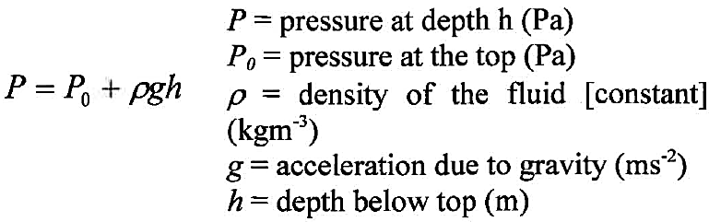
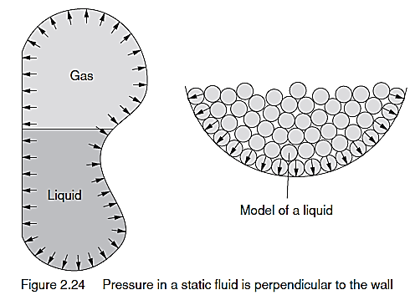
Worked example
A brick of mass 3 kg and dimensions 230 x 110 x 75 rests on a horizontal surface:
i flat on its largest face
ii on its end.
Determine the pressure applied to the horizontal surface in each case.
i F = mg
= 3 × 10
= 30 N
A = l × b
= 230 × 10-3 × 110 × 10-3
= 25 300 × 10-6mm2
p =
= 30 ÷ 25300 x 10-6
= 1.185 kPa
ii F = mg
= 3 × 10
= 30 N
A = b × t
= 110 × 10-3 × 75 × 10-3
= 8250 x 10-6 mm2
P =
= 30 ÷ 8250 × 10-6
= 3.636 kPa
As you can see the pressure is increased as the area is decreased. Note, the area was determined in mm², so the answer was in kPa.
Pressure in Liquids
Open container
A liquid at rest in an open container exerts a pressure due to its different weight at various depths.
1 Drill, or pierce, three small holes along the side of a large PET drink bottle at various heights – one near the bottom, middle and top.
2 Fill the container with water and observe the result.
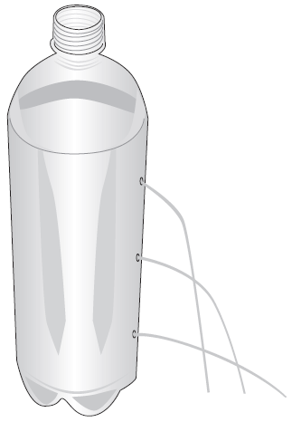
Figure 4.1 Water overflow from an open container
You should observe that the:
i pressure on the water in the open container varies with the depth; the greater the amount of water above the hole, the greater the pressure.
ii pressure exerted by the liquid is always perpendicular to the surface it contacts.
iii pressures are the same at all points on the same horizontal level in a liquid at rest.
Closed container
Now consider the pressures in a closed or sealed container.
Any pressure that is applied from outside a sealed container full of liquid can exert an equal and undiminished pressure to all other portions of the liquid and to the walls of the container.
1 Attach the PET drink bottle used in the previous activity to another intact PET drink bottle so the two join at the neck.
2 Fill the bottles with water, connect and squeeze the container without holes and observe the result.
Figure 4.2 Water flow from a closed container
You should observe that the pressure on the water in the sealed or closed container is the same for each of the holes.
This observation would also apply to connected sealed containers.

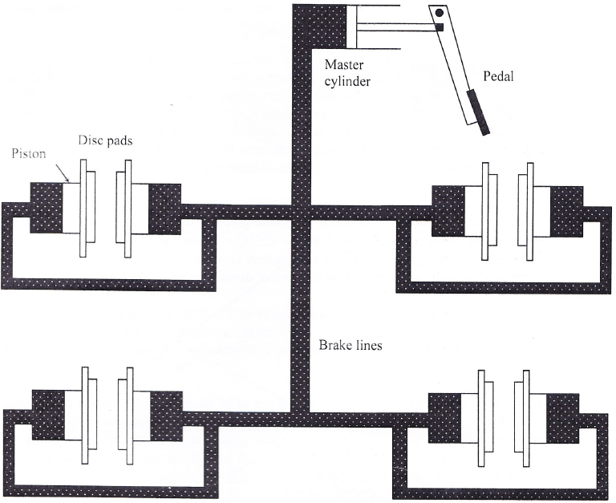

- Explain what is meant by a hydraulic system used in brakes.
____________________________________________________________________________________________________________________________________________________________________________________________________________________________________________________________________________________

- Define the term ‘pressure’.
_______________________________________________________________________________________________________________________________________________________________________________________________________________

- Define Pascal’s Principle.
____________________________________________________________________________________________________________________________________________________________________________________________________________________________________________________________________________________

- Define Hydrostatic Pressure.
____________________________________________________________________________________________________________________________________________________________________________________________________________________________________________________________________________________

- A concrete brick of mass 5 kg and dimensions 430 x 150 x 100 rests on a horizontal surface, flat on its largest face. Determine the pressure applied to the horizontal surface.

- The front wheel brakes provide approximately 67% of the braking forces due to ‘dipping’ of the car when braking. Explain how the hydraulic system is able to provide for this need for greater braking forces at the front wheels.
____________________________________________________________________________________________________________________________________________________________________________________________________________________________________________________________________________________

- A motorcycle braking system consists of a master cylinder acted on by the force of a brake lever. The Ø60 mm calliper cylinder is connected to the master cylinder as shown below. Determine the force the calliper piston exerts on the brake pad.
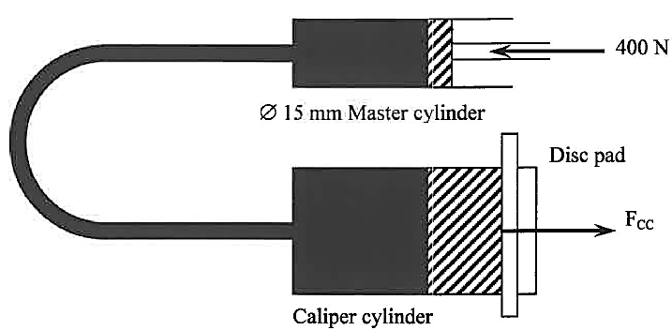
- Figure 4.20 represents a sealed hydraulic braking system. A force of 200 N is applied to the brake pedal as shown. Size details of the pedal, master cylinder, and front and back wheel cylinders are given on the diagram. Determine the thrust (force) delivered by each of the wheel cylinders.
Note the four steps needed to complete this question are set out in parts i, ii, iii, and iv.
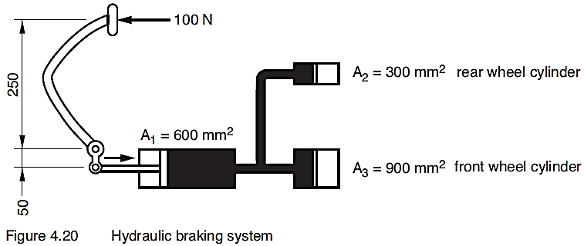
200N
- Determine by moments the resultant force on the master cylinder caused by the applied force of 200 N exerted on the brake pedal.

- Determine the pressure generated in the system by this resultant force.

- Determine the thrust at the rear wheel cylinder.

- Determine the thrust at the front wheel cylinder.

Engineering Materials

Microstructure of Steels
The iron - Carbon System
Pure iron exists at room temperature as a body-centred-cubic structure (BCC) called ferrite (or alpha iron) which shows on a magnified photograph of steel (or a photomicrograph) as white grains.
- Ferrite is soft and ductile and can only contain a very small amount of carbon in its structure (up to 0.04%). More ferrite in the microstructure results in a softer, tougher and a more ductile steel.
- Austenite is the name of the grain which forms when the steel is at red heat. Austenite can contain up to 2% carbon and is face-centred-cubic in structure (FCC) which is the reason why red hot steel is very soft and ductile - FCC is denser than BCC thus has more slip planes.
- Cementite - when steel cools from red heat, the austenite, which contains 2% carbon, changes to ferrite and cementite which forms because ferrite cannot absorb the excess carbon from austenite. Cementite is a compound of 3 iron atoms and one atom of carbon (Fe3C) and is extremely hard and brittle – like cement in concrete.
- Pearlite - on cooling from red heat the excess carbon from the austenite cannot be accepted by the ferrite so the carbon diffuses small distances (due to it being still solid) to form plates of cementite. This produces a layered structure (or lamellar structure) called pearlite made up of alternating bands of ferrite and cementite. Pearlite is so named because it looks like 'mother -of-pearl' under the microscope. Steels with a carbon content of 0.8% have only pearlite grains; pearlite is hard and strong and only half as ductile as ferrite.

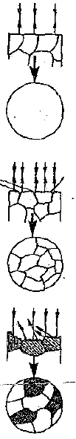
How Grains in Metals are made Visible
A smooth, polished metal surface will not show any detail because the light rays are reflected along the same path as they entered.

When the smooth surface is lightly etched (or ‘eaten’ by a special acid) the grain boundaries are attacked first (due to higher energy at grain boundaries) which produces small grooves thus making them visible.

Further etching will erode grains at different rates depending on grain orientation and produces visible grains. Heavy etching will result in the surface becoming too dark to differentiate individual grains and the surface must then be repolished.

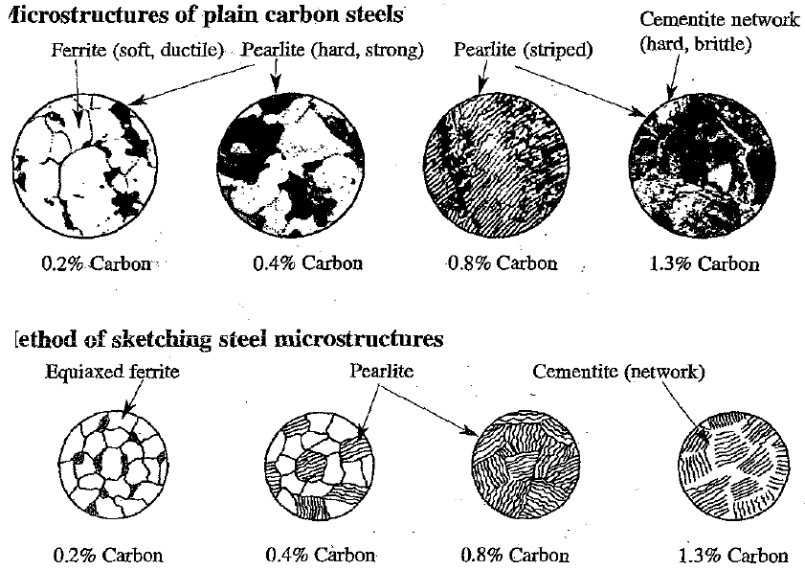

- Sketch equiaxed grains (= roughly circular) for annealed (= softened) materials and then fill in striped grains for pearlite.
- Always label microstructures.
- Do not make time consuming elaborate sketches.
- Proportions of ferrite/pearlite in annealed plain carbon steels are:
0% carbon = all white ferrite grains (no pearlite)
0.8% carbon = all striped pearlite grains (no ferrite grains)
0.4% carbon = half ferrite grains and half pearlite grains
0.2% carbon = 75% ferrite grains and 25% pearlite grains
0.6% carbon = 25% ferrite grains and 75% pearlite grains
>0.8% carbon = network of white cementite around grains of pearlite.

Steels
Plain Carbon Steels
Low carbon - up to 0.15% carbon
High ferrite content and can withstand large amounts of cold working – fence wire, rolling sheet, car bodies, stampings, rivets, black bar, chains
Mild steel 0.15 to 0.3 % carbon
Higher proportion of pearlite and is the most common type - very weldable and does not harden appreciably when heated and quenched. Used extensively for structural steels.
The above compositions have too little carbon to be heat treated.
Medium carbon steel 0.3% to 0.6% carbon
Predominately pearlite and are all heat treatable steels.
0.3% C - forgings, gears
0.4% C - wire, shafts, axles
0.5% C - dies, rails (wear resistant)
High carbon steel 0.55 to 1.0% -carbon
Predominately pearlite with a network of cementite above 0.8%; high strength and wear resistance -forming dies, spanners, hammers, punches, screwdrivers (i.e. all non-cutting tools), cables, prestressing tendons. .
Ultra-high carbon steel - 1.0 to 2.0% carbon
Increased network cementite - tool steels for files, knives, drills, taps, axes, generally used for cutting tools.
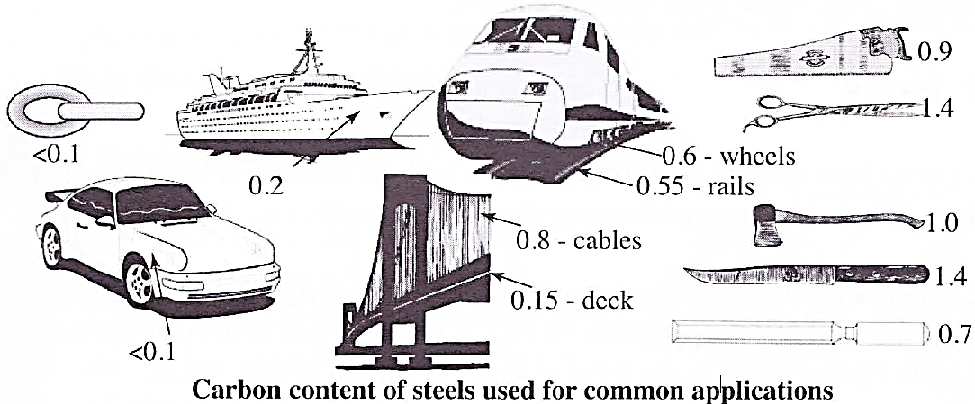

Alloy Steels
All commercial steels, in addition to iron and carbon contain manganese, silicon, sulphur and phosphorus in minor amounts. Metals used in alloy steels include:
Nickel: Increase toughness and fatigue resistance; used for high strength structural work.
Chromium: Gives good wear resistance, particularly for case hardening purposes. Used for ball and roller bearings; gives a hard case and tough, shock resistant centre.
Manganese and Silicon: These two elements are usually used together for a strengthening and toughening effect; used for gears, axles and shafts, punches and abrasion hardened steels.
Molybdenum: Increases high temperature hardness and strength; used for aircraft structural parts.
Tungsten: Good high temperature wear resistance; used for tool steels.
Vanadium: Strong carbide (cementite) former and limits grain growth, high toughness. Used for springs, crankshafts.
Stainless Steels: Steel alloys with a minimum of 10% chromium. The relatively high chromium content produces a passive surface film of chromium oxide which provides excellent corrosion resistance.
Austenitic Stainless Steel (16 to 26%Cr, >6%Ni, <0.1% C) – accounts for about 70% of production; presence of Ni produces stable austenite at room temperature; cannot be hardened except by cold working; high corrosion resistance due to high Cr/Ni content. Used for cookware, knives & forks, kitchen sinks and pressure vessels.
Ferritic Stainless Steel (12 to 25% Cr, <0.1 % C) – accounts for about 25% of production; cannot be hardened except for cold working; excellent corrosion resistance and deep drawing properties (ductility). Used for trim on cars, household appliance pressings, car exhaust systems, nuts, bolts, screws, hot water tanks, restaurant equipment
Martensitic Stainless Steel (12-18% Cr, 0.1 to 1.2% C)- small category of stainless steels; can be hardened by heat treatment. Used for turbine blades, ball bearings, in chemical and oil industries, surgical instruments and scissors
High Speed Steel: Contains most of the above alloying elements in varying amounts. Used for cutting tools - drills, taps and dies for thread cutting, power hacksaw blades, files, lathe tools, milling cutters.

Steels in Braking Systems
Steels have been used in braking systems for many years. They are ferrous metals that contain varying amounts of carbon along with other alloying elements.
Steels contain 0.05% – 1.4% carbon.
Commercial cast irons contain from 1.8% – 4% carbon.
Property/Structure Relationships
Property/structure relationships is very important in understanding steel and its use by engineers. The microstructure of steels and how the structure affects the properties of the various steels must be known
Equilibrium Structure
In steels, the equilibrium structure is very similar to the annealed structure and can be considered the same for this course. The structure of steel can be modified by heat treatment, therefore the type of structure shown must be specified.
The Microstructure of Steel
The microstructures show only two phases, ferrite and cementite. It is the amount of each phase and the distribution of the phases throughout the microstructure that determine the properties of the steel.
A Phase
A phase is a chemically distinct, homogeneous part of a material. Ferrite is one phase seen in the microstructure of steel, cementite is the other phase.
Ferrite: Ferrite is a very soft, ductile phase comprising of BCC iron with a very small amount of carbon dissolved in the iron. The amount of carbon dissolved varies with the temperature, ranging from 0.008% at room temperature to 0.025% at 723ºC.
Cementite: Cementite is a very hard, brittle phase comprising of Body Centred Cubic Structure (BBC) iron with 6.67% carbon dissolved in the iron. It is a compound and thus has a chemical formula, Fe3C.
Pearlite: Pearlite is a mixture of the two phases, ferrite and cementite and is therefore not a phase. It appears in most steel equilibrium microstructures. Pearlite is a lamella or plate-like structure with alternating thin plates of ferrite and cementite. It is a micro-constituent as it is a feature in the microstructure.
Now consider the property/structure relationships of various steels.
Dead mild steel – used in wheel rims, 1880s
- Composition: Iron, 0.05% to 0.15% carbon.
- Equilibrium Structure (0.15%): Equiaxed grains of ferrite, small grains of pearlite (approximately 12%). (Pearlite is a lamella structure, alternate thin plates of ferrite and cementite).
- Properties: Very soft, malleable, ductile, tough (due to ferrite matrix).
- Availability: Readily available, produced in Bessemer or Open-hearth furnace.
- Manufacturing technology, 1880: Hot rolled into strips, shaped and forge welded by blacksmith, heat shrunk onto rim.
- Manufacturing properties: Easily formed, soft, malleable, ductile.
- Service properties: Adequate hardness and toughness.
- Modification of properties: Can be work–hardened or alloyed.
- Microstructure: Phases, ferrite and cementite (12% of the structure is in the form of grains of pearlite, a lamella structure, thin alternating plates of ferrite and cementite).
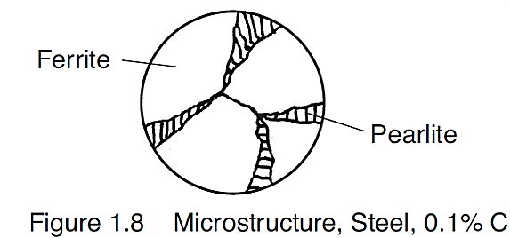
Mild steel – used in brake nuts and bolts, 1920s
- Composition: Iron, 0.15% to 0.3% carbon.
- Equilibrium Structure (0.3% C): Equiaxed grains of ferrite, small grains of pearlite, (approximately 30%).
- Properties: Soft, malleable, ductile, tough (due to ferrite matrix).
- Availability: Readily available, high steel production.
- Manufacturing technology 1920: Hot rolled into bars, hot forged to shape, thread, machine formed.
- Manufacturing properties: Easily formed by hot working, good machinability.
- Service Properties: Good shear and tensile strength, tough.
- Modification of properties: Can be work hardened or alloyed.
- Microstructure: Phases, ferrite and cementite (30% of the structure in the form of grains of pearlite, a lamella structure, thin alternating plates of ferrite and cementite).
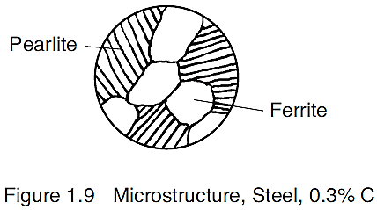
Medium carbon steel – used in brake springs, 1950s
- Composition: Iron, 0.3% to 0.6% carbon.
- Equilibrium Structure (0.6% C): Small equiaxed grains of ferrite, and large grains of pearlite, (approximately 75%).
- Properties: Tough, heat treatable, hard, good machinability.
- Availability: Readily available, very high steel production.
- Manufacturing technology 1950: Hot rolled into rods, hot drawn to wire shape. Methods of producing springs; draw into wire, form the helical shape, harden and temper the spring.
- Manufacturing properties: Good formability by hot working, heat treatable to produce ‘spring’ properties.
- Service properties: Resilient, high elasticity, not corroded by brake fluid.
- Modification of properties: Can be heat treated to produce different properties, or alloyed.
- Microstructure: Phases, ferrite and cementite (75% of structure grains of pearlite).
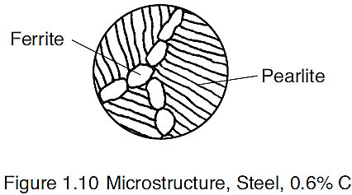
Eutectoid steel – used in brake cable wire, 1950s
Note eutectoid steel is steel that contains 0.8% carbon
- Composition: Iron, 0.8 % carbon.
- Equilibrium Structure (0.8% C): Grains of pearlite, (100%).
- Properties: Heat treatable.
- Availability: Readily available, very high steel production.
- Manufacturing technology 1950: hot rolled into rods, hot drawn to wire.
- Manufacturing properties: Good formability by hot working.
- Service properties: Good toughness and high tensile strength.
- Modification of properties: Can be heat treated to produce different properties, or alloyed.
- Microstructure: Phases, ferrite and cementite in the form of grains of pearlite.
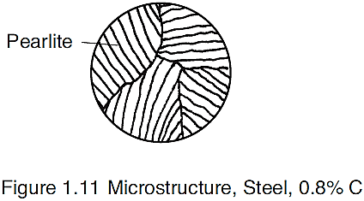
High carbon steel – used in brake cable wire, 1950s
- Composition: Iron, 0.6% to 0.9 % carbon.
- Equilibrium Structure (0.9% C): Grains of pearlite surrounded by a continuous precipitation of cementite at the grain boundaries.
- Properties: Heat treatable, hard with low ductility, (brittle) high tensile strength, poor machinability.
- Availability: Readily available, very high steel production.
- Manufacturing technology 1950: Hot rolled into rods, hot drawn to wire.
- Manufacturing properties: Good formability by hot working, heat treatable.
- Service properties: Good toughness and high tensile strength.
- Modification of properties: Can be heat treated to produce different properties, or alloyed.
- Microstructure: Phases, ferrite and cementite in the form of grains of pearlite, surrounded by a continuous precipitation of cementite at the grain boundaries.
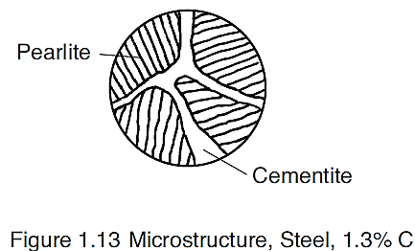

- List three reasons pressed medium carbon steel, used in early drum brakes, was not satisfactory.
________________________________________________________________________________________________________________________________________________

- Name three steels used for brake drums prior to the 1970s.
________________________________________________________________________

- Draw the microstructures for the following steels; 0.15%; 0.35%; 0.8% and; 1.1% carbon steels and label the phases present in each microstructure.
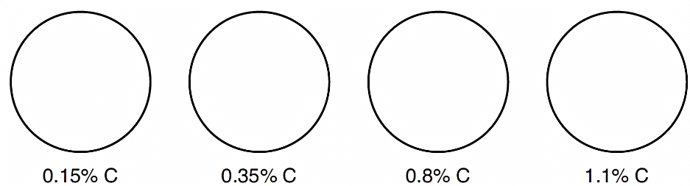
- Outline the properties of both of the phases listed below.
Ferrite: _________________________________________________________________
________________________________________________________________________
Cementite: ______________________________________________________________
________________________________________________________________________

- Describe the structure of pearlite, and name the phases that are present in pearlite.
________________________________________________________________________________________________________________________________________________________________________________________________________________________

- For each of the four steels nominated above:
- List two mechanical properties of the steel
- Explain in terms of the microstructure, why the steel possesses these properties.
- List two methods that may be used to modify these properties.
- Give one example where the steel could be used in brakes.

0.15% carbon steel
Two mechanical properties: ____________________________________________________
___________________________________________________________________________
Microstructure/properties: ______________________________________________________
______________________________________________________________________________________________________________________________________________________
Modification of properties: _____________________________________________________
___________________________________________________________________________
Use in brake systems: _________________________________________________________
______________________________________________________________________________________________________________________________________________________

0.35% carbon steel
Two mechanical properties: ____________________________________________________
___________________________________________________________________________
Microstructure/properties: ______________________________________________________
______________________________________________________________________________________________________________________________________________________
Modification of properties: _____________________________________________________
___________________________________________________________________________
Use in brake systems: _________________________________________________________
______________________________________________________________________________________________________________________________________________________

0.8% carbon steel (Eutectoid steel)
Two mechanical properties: ____________________________________________________
___________________________________________________________________________
Microstructure/properties: ______________________________________________________
______________________________________________________________________________________________________________________________________________________
Modification of properties: _____________________________________________________
___________________________________________________________________________
Use in brake systems: _________________________________________________________
______________________________________________________________________________________________________________________________________________________

1.1% carbon steel
Two mechanical properties: ____________________________________________________
___________________________________________________________________________
Microstructure/properties: ______________________________________________________
______________________________________________________________________________________________________________________________________________________
Modification of properties: _____________________________________________________
___________________________________________________________________________
Use in brake systems: _________________________________________________________
______________________________________________________________________________________________________________________________________________________

Cast Iron in Braking Systems
Another ferrous metal that has a wide ranging use in braking systems is cast iron. A materials engineer must be familiar with the structure of the cast irons and the relationship between the structure and the properties.
Property/structure relationships
By definition steel never contains more than 2 % carbon. If that amount is exceeded then the alloy is considered a cast iron. These are complex alloys that are primarily iron with between 2.5 and 5% carbon (usually 3 to 4%). In fact, if not for some of the alloying elements cast iron would be of little use.
Cast iron is desirable as an engineering material because:
- It is a relatively cheap material, not far removed from raw pig iron.
- Compressive strength and rigidity are good.
- It is easily machined if correct composition used.
- Good fluidity when molten means it flows well in castings.
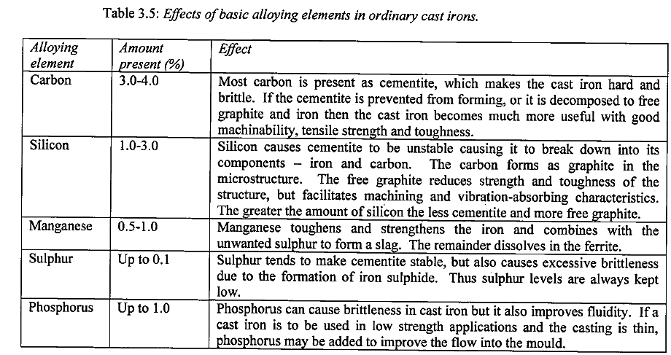
The Microstructure of Cast Iron
Interpretation of the structure of cast iron and the drawing of the microstructure is vital to the interpretation of the syllabus in terms of the properties of that material.
Except for white cast iron, the microstructures show three phases, ferrite, cementite and graphite. The amount of each phase, the distribution of the phases throughout the microstructure and the shape of the graphite phase determines the properties of the cast iron.
A reminder, ferrite is a very soft, ductile phase and cementite is a very hard, brittle phase.
Graphite: Graphite has little mechanical strength. The microstructural shape of the graphite determines many of the properties of the cast iron.
Graphite exists as flakes in the microstructure of grey cast iron. The flakes have sharp ends. It is the sharp ends of the graphite flakes that are responsible for the grey cast iron having a very low tensile strength. Under tensile loading stress concentration occurs at the sharp ends. This stress concentration causes the cast iron to fracture at a low tensile loading.
Graphite nodules and rosettes – Graphite exists as nodules in spheroidal graphite cast iron and as rosettes in malleable cast iron. These shapes do not cause stress concentration.
Steel Matrix: The matrix surrounding the graphite can be ferrite, pearlite or a combination of each. The matrix is often referred to as a ‘steel’ matrix to describe this occurrence.
White cast iron – used in dies and wearing plates, 1950s
- Composition: Iron: 1.8% to 3.6% carbon; 0.5% to 2.0% silicon.
- Structure: Dendrites of pearlite in a matrix of cementite.
- Properties: Very hard, zero ductility, (extremely brittle), not machinable.
- Availability: Readily available, high production.
- Production technology: Cast to shape, rapid cooling.
- Manufacturing properties: Excellent castability.
- Service properties: Extremely hard, strong in compression.
- Modification of properties: Can be heat treated to produce pearlitic or ferritic malleable cast iron.
- Microstructure: Phases, ferrite and cementite in the form of dendrites of pearlite, surrounded by a matrix of cementite.
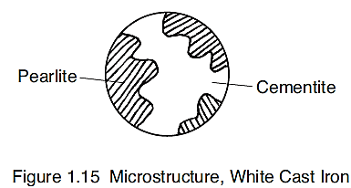
Grey cast iron – used in brake master cylinders, 1970s
- Composition: Iron; 2.4% to 3.6% carbon; 1.0% to 3.0% silicon.
- Structure: Graphite flakes in a ‘steel’ matrix of either pearlite or ferrite, or a combination of both.
- Properties: Relatively soft and machinable. Strong in compression but weak in tension.
- Availability: Readily available, high production.
- Production technology: Cast to shape, moderate cooling produces pearlitic grey cast iron, slow cooling produces ferritic grey cast iron.
- Manufacturing properties: Excellent castability, excellent machinability
- Service properties: Not corroded by brake fluid, strong in compression.
- Modification of properties: Pearlitic grey cast iron can be heat treated to produce a ferritic matrix.
- Microstructure: Pearlitic grey cast iron; phases, graphite flakes in a matrix of ferrite and cementite in the form of pearlite.
Ferritic grey cast iron; phases, graphite flakes in a matrix of ferrite.
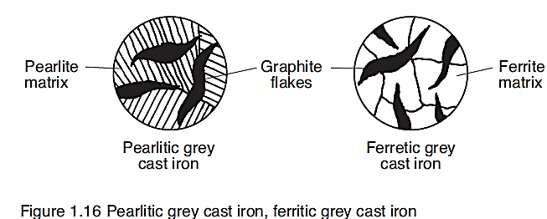
Malleable cast iron – used in brake shoes, 1970s
- Composition: Iron; 1.8% to 3.6% carbon, 1.0% to 3.0% silicon.
- Structure: Graphite ‘rosettes’ in a ‘steel matrix’ of either pearlite or ferrite, or a combination of both.
- Properties: Soft and ductile, malleable, tough, machinable.
- Availability:Readily available.
- Production technology: White cast iron reheated to 800º C and soaked for 30 to 50 hours. Moderate cooling produces pearlitic malleable cast iron, slow cooling produces ferritic malleable cast iron.
- Manufacturing properties: Good ductility, excellent machinability.
- Service properties: Tough, strong in tension and compression.
- Modification of properties: Pearlitic malleable cast iron can be heat treated to produce a ferritic matrix.
- Microstructure: Pearlitic malleable cast iron; phases, graphite rosettes in a matrix of ferrite and cementite in the form of pearlite.
Ferritic malleable cast iron; phases, graphite rosettes in a matrix of ferrite.
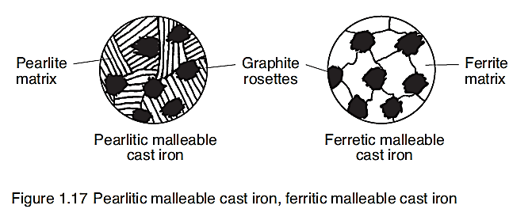
Spheroidal graphite cast iron – used in brake discs, 1980s
- Composition: Iron; 3.0% to 4.0% carbon, 1.8% to 3.0% silicon.
- Structure: Graphite ‘spheroids’ in a ‘steel matrix’ of either pearlite or ferrite, or a combination of both.
- Properties: Soft and ductile, malleable, tough, machinable.
- Availability: Readily available since the 1960s.
- Production technology: Addition of magnesium produces nodules of graphite in a ‘steel’ matrix. Moderate cooling produces pearlitic spheroidal graphite CI, slow cooling produces ferritic spheroidal graphite cast iron.
- Manufacturing properties: Good ductility, excellent machinability
- Service properties: Tough, strong in tension and compression.
- Modification of properties: Pearlitic spheroidal graphite cast iron can be heat treated to produce a ferritic matrix.
- Microstructure: Pearlitic spheroidal graphite cast iron; phases, graphite nodules or spheres in a matrix of ferrite and cementite in the form of pearlite.
- Ferritic spheroidal graphite cast iron; phases, graphite nodules or spheres in a matrix of ferrite.
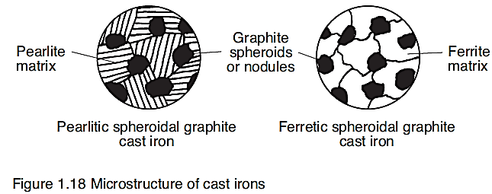

- Until the 1970s grey cast iron was the main material used for brake drums and brake discs.
- Draw the microstructure of grey cast iron
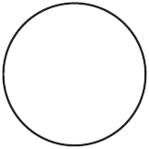
- List and explain the reasons for suitability as brake drum material:
________________________________________________________________________________________________________________________________________________

- Name the material that was used to manufacture brake drums after the 1970s.
___________________________________________________________________________

- Draw the microstructures for white cast iron, grey cast iron and spheroidal graphite cast iron and label the phases present in each microstructure.
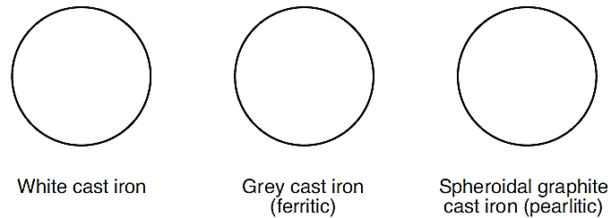
- Outline the properties of the phases listed below.
Graphite: ________________________________________________________________
________________________________________________________________________
Ferrite: __________________________________________________________________
________________________________________________________________________
Cementite: ______________________________________________________________
________________________________________________________________________

- For each of the four cast irons nominated above:
- List two mechanical properties of the cast iron.
- Explain in terms of the microstructure, why the cast iron possesses these properties.
- List two methods that may be used to modify these properties.
- Write your recommendation for use of the cast iron in the production of brake discs, brake drums and wheel cylinders.

White Cast Iron
Two mechanical properties: ____________________________________________________
___________________________________________________________________________
Microstructure/properties: ______________________________________________________
______________________________________________________________________________________________________________________________________________________
Modification of properties: _____________________________________________________
___________________________________________________________________________
Recommendation: ____________________________________________________________
______________________________________________________________________________________________________________________________________________________

Grey Cast Iron (ferritic)
Two mechanical properties: ____________________________________________________
___________________________________________________________________________
Microstructure/properties: ______________________________________________________
______________________________________________________________________________________________________________________________________________________
Modification of properties: _____________________________________________________
___________________________________________________________________________
Recommendation: ____________________________________________________________
______________________________________________________________________________________________________________________________________________________

Spheroidal Graphite Cast Iron (Pearlitic)
Two mechanical properties: ____________________________________________________
___________________________________________________________________________
Microstructure/properties: ______________________________________________________
______________________________________________________________________________________________________________________________________________________
Modification of properties: _____________________________________________________
___________________________________________________________________________
Recommendation: ____________________________________________________________
______________________________________________________________________________________________________________________________________________________

Composite Materials for Braking Systems
Many composites are used in engineering, including cements, asphalt, glass reinforced polymers, timber laminates and plywood.
A composite material consists of two or more materials combined to form the composite. The composite utilises the properties of the individual materials to give distinctly different service properties to the manufactured composite product.
When selecting materials to form a composite, the following must be considered:
- Properties of the individual materials
- Cost of the materials
- Manufacturing properties
- Cost of production
- Macrostructure or microstructure of the final composite
- Service properties required of the component.

Composite Material for a Brake Pad
The ultimate brake pad composite material is light, inexpensive, highly effective, maintains its effectiveness under extreme conditions, requires little or no maintenance, can last the life of the vehicle and is environmental friendly.
Specific service properties for brake pads
Uniform friction properties. The coefficient of friction should not vary appreciably with variation of load, temperature, and velocity. The brakes must stop the vehicle.
- High thermal stability; resistance to thermal shock and fatigue. The material should not break down due to temperature variations.
- Low noise generation. Noise and brake-squealing must be kept to a minimum.
- Adequate compressive and shear strength. The composite should not shear or fail through compressive stress.
- Suitable hardness. Only minimal wearing or scoring of surfaces, including the disc and the pads should occur.
- Suitable toughness. The pad must be able to withstand impact loads.

Materials Used in Brake Liners and Pads
Sintered Metal Composites
Modern cars use a sintered metal composite for brake linings. The brake linings consist of metal particles, usually steel fibres and/or copper fibre and/or brass chips along with a mixture of all or some of the following, Kevlar® pulp, mineral wool, glass fibres, phosphate fibres, carbon black and friction modifiers (alumina, mica, iron oxide, graphite and rubber). These are pressed and bonded together with a phenol formaldehyde resin. The metal particles offer good heat dissipation, which makes the linings resistant to brake fade. They have a stable coefficient of friction.
Some pads were made with no metal particles but they were found to wear quickly and squealed on application. Copper is often added to improve heat dissipation for high-speed use, and the steel fibres are annealed to reduce hardness and thus wear on the cast iron disc rotors or drums. There are many different formulations and their make-up depends on the application.
Bendix's Metal King Plus is primarily made up of iron powder, graphite and steel grit, whereas the AKM pads for four wheel drives primarily uses barytes (native barium sulphate), and larger amounts of alumina and Kevlar® to resist brake fade when used off-road.
Asbestos
Asbestos has been used in braking materials for most of this century because of its friction properties, strength, low cost and good thermal qualities.
During the past 25 years, requirements for braking materials have dramatically changed. There is a tendency towards smaller friction elements operating at higher temperatures and pressure. Asbestos does not fulfil the requirements needed for heat resistance at much higher temperatures, higher coefficient of friction, nor the extended durability required in today’s brakes.
Health and safety risk
As you may know, asbestos also represents a serious occupational health and safety risk. It has been proved that exposure to asbestos can lead to asbestosis, a form of lung cancer. For this reason many countries have banned the use of asbestos.
Fibres – a replacement for asbestos
Research to find a replacement for asbestos fibres has included investigation of steel wool, glass fibre, wool fibre, aramid (aromatic polyamide polymer) fibre, kevlar and carbon fibre.
Required properties of fibres for brake pads include:
- Good friction properties
- Good processing performance
- High reinforcing effectiveness
- High shear and compressive strength
- Good adhesion to binding matrix
- Adequate heat resistance
- Low specific gravity.
Research for replacement fibre
Let us consider two replacements; glass fibre and carbon fibre.
Glass fibre
Glass fibre is very hard and can abrade the drum or disc. It is brittle, and thus requires care when mixing into the friction compound to prevent breakage. It softens at high temperatures, acting as a lubricant, producing a sudden loss of friction. It has excellent binding properties with the matrix, is able to be produced in long and short fibres giving good dimensional stability, rigidity and strength to the final product.
Carbon fibre
Carbon fibre has been around for more than a century, with Thomas Edison utilised carbon filament in his newly invented electrical light bulb. Up until the late seventies it was used in composits for brakes in the aerospace industry, racing cars and high performance military aircraft. In the early eighties it was used in the brakes of the Concorde.
In 1975 research was accelerated to find a relatively cheap multipurpose carbon fibre similar to the fibre used in the aerospace and sporting goods industries.
Properties of Carbon Fibre for Brake Pad Materials
Carbon fibre properties as related to braking materials include:
- High strength, equal to or better than steel
- Light weight, 20% that of steel
- High temperature resistance, MP greater than 3000º C
- Resistance to oxidation, even at high temperature
- Low thermal expansion, maintaining dimensional stability
- Self lubricating
- Good wear resistance
- Excellent reinforcing properties, long and short fibres
- Good coefficient of friction with cast iron
- Still expensive.
Matrix for Brake Pads
The matrix is the continuous phase in the braking composite that holds or ‘glues’ the materials and fibres together. It must bind with the other ingredients, be tough and strong in shear and compression, and have good thermal shock resistance.
The most common matrix is phenol-formaldehyde or a modified phenolic.
Fillers for brake pads
Fillers are generally low cost materials, such as clay or calcium carbonate that are added to extend the material in the composite, occupy space and reduce costs. They usually influence wear properties of the composite.
Friction Modifiers
Friction modifiers are many and varied. Some are listed below.
- Metal chips, used to modify friction properties, and to control cleanliness on the brake interface.
- Lead and zinc, low temperature frictional properties.
- Copper and brass, high temperature frictional properties.
- Lubricants, such as graphite and carbon black powder are added to suppress noise and provide protection against disc wear.
- Friction ‘dust’ or powder, such as cross linked phenolic and modified phenolic based polymers, are used to provide thermal stability, reduce the wear factor and to provide even friction properties under extreme conditions.
- Barium sulphate, used to improve the wear resistance of the friction material at low temperatures, accelerate the curing of the binder and improve compressive and shear strength.
Manufacture of Brake Pads
Brake pads are manufactured by compression moulding. Compression moulding consists of compressing raw material into a cavity or mould of the desired shape and applying heat and pressure.
Batch Formulation
Batching is the combining or premixing of the materials in preparation for forming.
There are many combinations of these materials that may be used to form braking materials. Batch formulas contain up to ten or even fifteen materials, combined together. Generally the matrix or binder is 10–25%, the fibre, 15–30%, non-organic fillers, 10–20%, metals 1–8%, friction dust 3–10%, and other modifiers 3–15%.
Batching
During batching, the powdered phenolic and fillers are first blended, modifiers are added and mixed. The fibres are added last to minimise fracture in the mixing process.
Pre-forming
Pre-forming is used to economise in the use of materials. A predetermined amount of the batched material is cold pressed into a pre-form mould at a pressure of 7–15 MPa. This pre-formed shape is then placed into the cavity of the compression moulding machine,
Compression Moulding
The cavity and plunger of the mould are attached to a compression press. The mould is heated to a temperature of 130–190º C, depending upon the polymer. The pre-formed batched material is then placed into the hot mould and put under pressure of 14–50 MPa. The material softens and is compressed into the shape of the mould cavity.
Post-cured
The finished product is then post-cured in an air-forced oven, at 150–200º C for several hours. The cure time depends upon the thickness of the product, the polymer used, its state of polymerisation when charged into the mould, the mould temperature, and the moulding pressure used
Finishing
The brake pads then undergo thickness grinding.
Brake liners require edge grinding to width, inside and outside grinding to thickness, squaring and cutting to length, and drilling where appropriate.

- Define the term ‘composite material’.
_______________________________________________________________________________________________________________________________________________________________________________________________________________

- When studying a composite material it is important to consider the individual materials that are combined to form that composite. Explain why this is important.
____________________________________________________________________________________________________________________________________________________________________________________________________________________________________________________________________________________

- Service properties are the first consideration for the materials engineer when designing a composite for brake pads. List four of these service properties.
__________________________________________________________________________________________________________________________________________

- Asbestos is now considered unsuitable to be used as a fibre in brake pad composites. List three reasons why asbestos is no longer suitable for use in brake pads.
__________________________________________________________________________________________________________________________________________

- Carbon fibre is used in braking material in aircraft and high powered motor vehicles. List three properties of carbon fibre that makes it suitable for use in brake composites.
__________________________________________________________________________________________________________________________________________

- Metal chips, such as zinc, are used in brake pad composites. State the specific reasons for using zinc.
_______________________________________________________________________________________________________________________________________________________________________________________________________________

- The term batching is used when referring to composite materials. Explain the meaning of batching.
_______________________________________________________________________________________________________________________________________________________________________________________________________________

- Name and briefly describe the method of manufacture used to shape brake pads.
____________________________________________________________________________________________________________________________________________________________________________________________________________________________________________________________________________________

Testing of Materials
Compression & Tension Testing
These tests are used to determine the tensile and compressive properties of a material. The tension test usually involves using some machine to stretch a test piece, whereas a compression test squeezes the test piece. A tensile testing machine usually consists of a set of grips to hold the test piece and either a screw thread or hydraulic system to place the object into tension. There will be either a revolving drum or a computer linked to the tester to record the load extension diagram.
The manufacturing methods and techniques used to shape materials quite often depend upon plastic deformation. These processes include forging, rolling, extrusion, and wire and rod drawing. Sheetmetal processing, folding, pressing, deep drawing and spinning also rely upon plastic deformation.
In all of these processes the material is subjected to tensile, compressive and shear forces. The relationship between a force and the deformation it produces is required knowledge for the engineer in manufacturing. Two of the most important mechanical property tests are the tensile test and compressive test.
Analysis of the curve produced during a load-deformation test can provide information essential to the mechanical engineer. Yield stress, ultimate tensile stress (UTS), modulus of elasticity, percentage elongation, and percentage reduction in area can be determined along with interpretation of properties such as ductility and toughness.
Tensile Tests
Tensile tests are conducted using a tensometer or a universal testing machine. A prepared specimen, usually of standardised size, is held in a gripping device and a gradually increasing axial load applied to the specimen. The load is usually applied until fracture occurs, alternatively, it may only be applied within the elastic limit, or up to the yield point in some tests.
The applied load is plotted, usually automatically, against the extension, to produce a load-extension graph or curve.
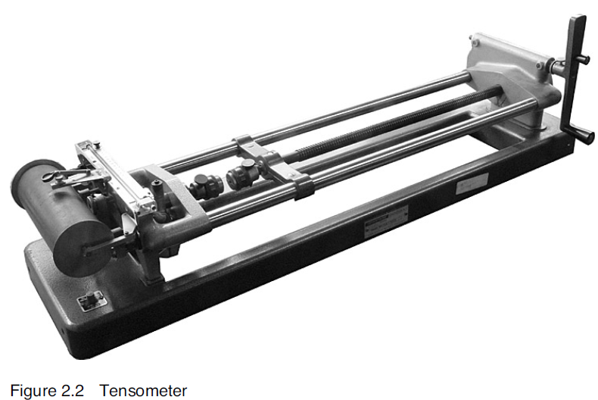
A lot can be determined from the load/extension or stress/strain diagrams from a tensile test. The image below shows four different stress strain diagrams and what properties their general shape displays.

Compressive Tests
Compressive tests can also be conducted using a tensometer, with a special adaptor, a universal testing machine, or a specialised compression testing machine. The test is similar to the above except that a compressive load is applied. It is essentially a tensile test in reverse.
In ductile materials barreling usually occurs in the specimen. This is due to the frictional forces existing between the ends of the specimen and the surface of the dies that retard the free flow or expansion of the material. The resulting shape is similar to that of a barrel, the middle has expanded while the ends have not.
Malleable materials will tend to deform while brittle materials will display characteristic breakage. The image below shows some of the possible fractures when testing concrete and cast iron.
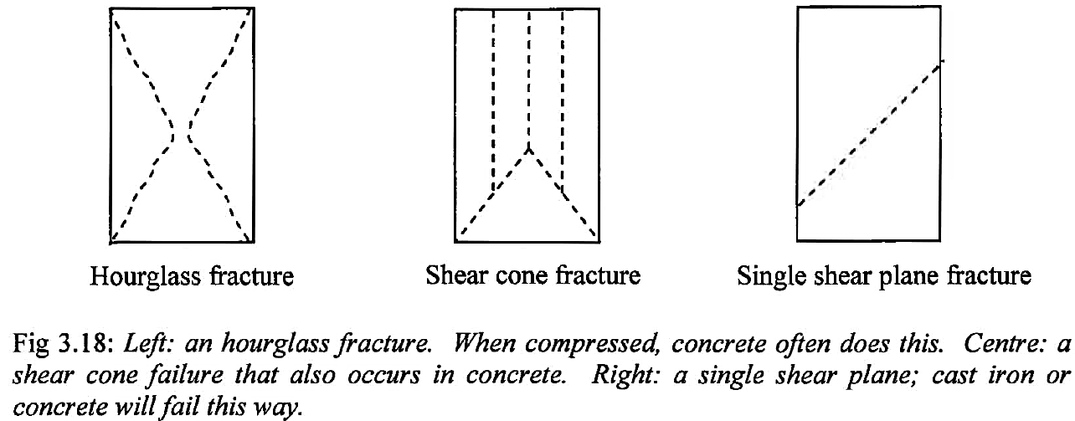

Load-deformation verses stress/strain curves
To be able to compare different materials and similar or the same materials, a standardised specimen is used, or better still the load-deformation diagram is converted to a stress-strain diagram. This allows comparisons to be validly made.

Hardness Testing
Hardness is a measure of a material’s resistance to indentation, abrasion, machining or scratching. Engineering tests use resistance to indentation as a basis for hardness testing.
Hardness tests are non-destructive tests. They are used in industry to verify that the required properties have been produced following the heat treatment of components during production. They are used for control or production line testing, as well as for research, and comparison testing
The three common standardised hardness tests include: Brinell, Vickers and Rockwell. All three use machines which apply a specified load to an indentor. The indentation is then measured to give the tested material a hardness number.
Brinell Hardness Test
The Brinell hardness test was introduced in 1900 by Swedish metallurgist J. A. Brinell.
Method: A hardened steel or tungsten carbide ball indentor is pressed into the surface of a material for 10–15 seconds. The loads used are 500, 1 500 and 3 000 kg.
Measured: The diameter of the indentation is measured using a low-powered graduated microscope, and the Hardness Brinell number determined from a prepared table.
Recorded: The hardness number is given, followed by the letters HB, then by numbers indicating the diameter of the ball and the load used for the test. For example 250 HB 10/3000, indicates that a Brinell Hardness test number of 250 was obtained using a 10 mm diameter ball and a load of 3 000 kg.
Application: Used for materials such as cast iron, due to the large indentor giving an ‘average’ hardness. Used for very hard material, or for plated or hardened surfaces.
Vickers Hardness Test
Vickers hardness test was introduced in 1922 in England by R. Smith and G. Sunderland.
Method: An industrial diamond indentor in the shape of an inverted square pyramid is pressed into the surface of a material for 15 seconds.
Measured: The surface area of the indentation is determined, and the Hardness Vickers number read from prepared tables. The numbers have been calculated by dividing the load by the surface area of the indentation.
Recorded: The hardness number is given, followed by the letters HV, then by a number indicating the load used for the test. For example, 650 HV 30, indicates a Vickers Hardness test number of 650 was obtained using a load of 30 kg.
Application: Used for a full range of materials with a wide range of hardness. It is used for sheet metal, for very hard material, and for case hardened surfaces.
Rockwell Hardness Test
The Rockwell hardness test was introduced in 1922 by American metallurgist S. P. Rockwell.
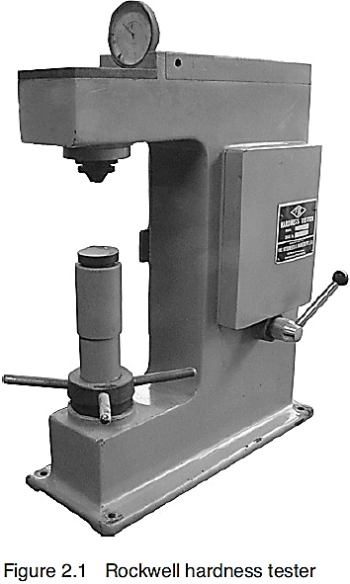
Method: A variety of indentors are used, including an industrial diamond cone, and a 1.5 mm and 3 mm hardened steel ball. The indentor is initially pressed into the surface of the material by a minor load of 10 kg and the dial indicator is set to zero. The major load is then applied. When the dial indicator is steady, the major load is removed.
Nine scales of hardness are available from A to K, having various indentors used with different major loads for various materials. The most common Rockwell tests are B and C.
The Rockwell B test uses a 1.5 mm hardened steel ball, with a major load of 100 kg. It is used for testing softer metals such as copper, brass, aluminium, malleable cast iron and grey cast iron.
The Rockwell C test uses an industrial diamond cone, with a major load of 150 kg. It is used for testing harder metals such as white cast iron, hardened and case hardened steel.
Measured: The difference in depth of the indentation caused by the minor and major loadings is used as the measure of hardness. The hardness number is read directly from the dial using the appropriate scale for that test. This direct reading enables the Rockwell testing to be done quickly and accurately during the actual production of the component. The test can also be automated.
Recorded: A number indicating the related hardness of the material for that scale, followed by HR and the appropriate letter for the Rockwell Hardness test used, is given. For example, 60 HRC indicates a test hardness number of 60 was obtained using the appropriate load and indentor for the Rockwell C hardness test.
Application: Used for a full range of materials with a wide range of hardness.

- Briefly describe the methods used for a tensile test.
_______________________________________________________________________________________________________________________________________________________________________________________________________________

- Briefly describe the methods used for a compressive test.
_______________________________________________________________________________________________________________________________________________________________________________________________________________

- Define the term hardness.
_______________________________________________________________________________________________________________________________________________________________________________________________________________

- Hardness testing is described as a non-destructive test. Explain the meaning of non-destructive test.
_______________________________________________________________________________________________________________________________________________________________________________________________________________

- Name and discuss two areas where hardness tests are used in industry.
____________________________________________________________________________________________________________________________________________________________________________________________________________________________________________________________________________________

- Name and briefly describe three standardised hardness tests used in industry.
____________________________________________________________________________________________________________________________________________________________________________________________________________________________________________________________________________________
____________________________________________________________________________________________________________________________________________________________________________________________________________________________________________________________________________________
_____________________________________________________________________

Communication

Isometric Circles
In this section you will learn how to draw isometric circles, both freehand and by using the following instruments; a 60°–30° set square and a set of compasses.
Most engineers would use freehand methods, or if necessary, use isometric ellipse templates. CAD systems could also be used. However, the freehand method for quick visualisation is the most useful.
Four centre method to construct an isometric circle
A circle can be divided into four quadrants, or conversely, you could draw four quadrants to form a circle. A circle in isometric projection, using the four centre method, is represented by combining four separate isometric quadrants. The two figures below, show a circle and an isometric ‘circle’; (actually an ellipse).

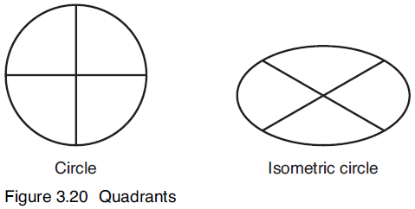

Drawing a quadrant in isometric projection
Method:
- Draw the corner that contains the quadrant.
- Accurately mark off the radius from the corner, along each side to locate the contact points.
- Draw lines at 90º to the sides from these contact points.
- Where these lines meet is the centre for the quadrant.
- Check accuracy to each contact point and draw the quadrant.

The two figures below show the method of constructing a true quadrant, and its application to an isometric quadrant in a horizontal surface.

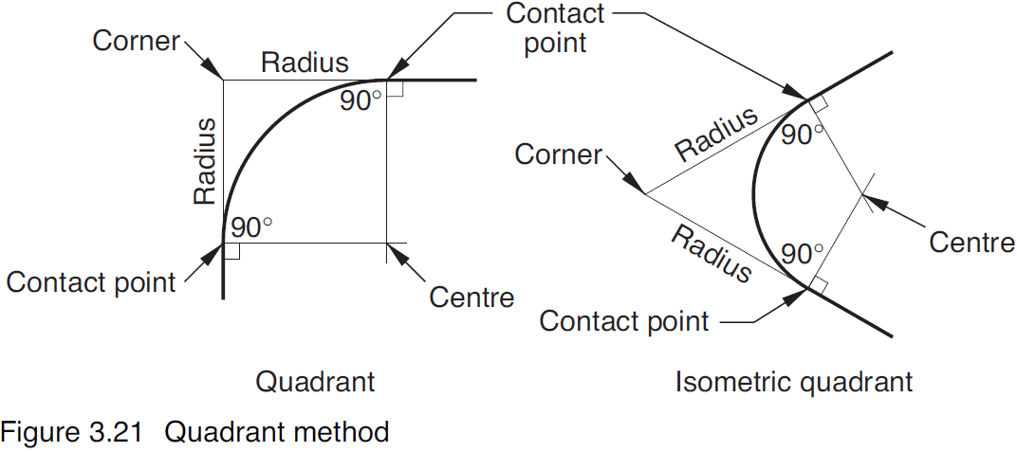
Drawing an Isometric Circle in a Horizontal Face
The quadrant method given on the previous page is used to construct the isometric circle.
Four quadrants are combined to form the isometric circle.
Method:
- Draw the isometric square having sides equal in length to the diameter of the required circle using very light construction lines.
- Locate and mark the middle of each side of the square – these middle points represent the contact points for each quadrant.
- Draw lines at 90º to the sides of the square from these middle or contact points where these lines intersect are the centres for each of the quadrants.
- Set your compasses at a radius equal to the distance from the centre to the contact points (note that this radius will not be 25 mm).
- Check your accuracy and draw the quadrant.
- Complete the other three quadrants to form a full circle.
Two of the four corners are represented below, the quadrants are shown.
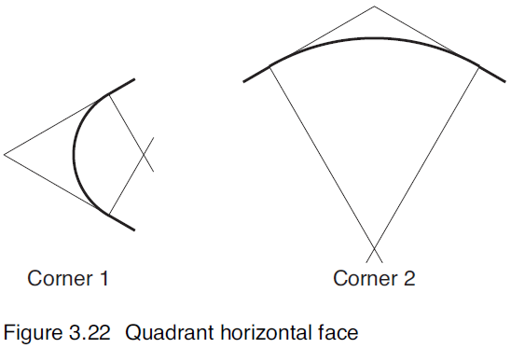
The four centre method is used to draw an isometric circle of radius 25 mm in a horizontal face.
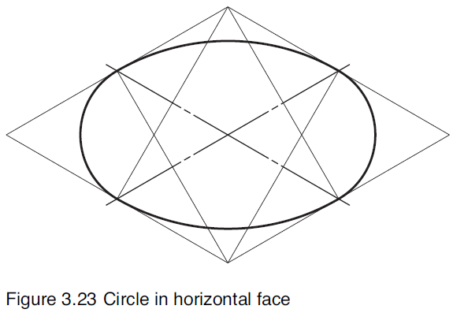
Drawing an Isometric Circle in a Vertical Face
The quadrant method given on the previous pages is used to construct the isometric circle.
Four quadrants are combined to form the isometric circle.
Method:
- Draw the isometric square having sides equal in length to the diameter of the required circle using very light construction lines.
- Locate and mark the middle of each side of the square – these middle points represent the contact points for each quadrant.
- Draw lines at 90º to the sides of the square from these middle or contact points where these lines intersect are the centres for each of the quadrants.
- Set your compasses at a radius equal to the distance from the centre to the contact points (note that this radius will not be 25 mm).
- Check your accuracy and draw the quadrant.
- Complete the other three quadrants to form a full circle.
Two of the four corners are represented below, the quadrants are shown.

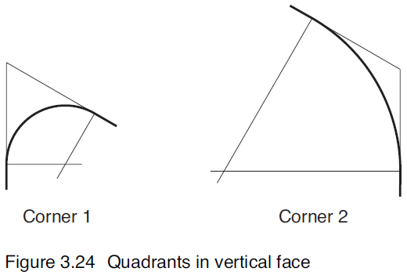
The four centre method is used to draw an isometric circle of radius 20mm in a vertical face.
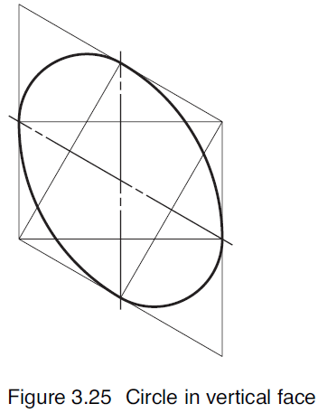
Projecting an Isometric Quadrant to another Face
The following drawings show you a method of projecting the quadrant to another face. You could fully construct another quadrant, but it is quicker to use the methods shown below.
From a horizontal plane, no profile edge
Method:
- Project downward from the centre point and the two contact points towards the new surface using very light construction lines.
- Set your dividers to the given thickness and accurately mark off the distance to the new surface, down from the centre point and the two contact points.
- Check accuracy then draw the quadrant for the new surface.
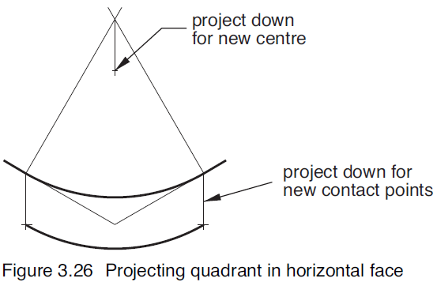
From a horizontal plane, with a profile edge
A profile or outer edge of a solid object will hide part of the quadrant in the lower face. You therefore do not have to draw the whole quadrant in this lower face; only half of the quadrant will be visible.
Method:
- Draw the quadrant in the top face, then project downward, as described below, to the lower face.
- Project downward from the centre point and the contact point towards the new surface using very light construction lines.
- Project downward the profile edge (note the profile edge is a line tangential to the quadrants that represents the outside edge of the object).
- Set to the required thickness of the object, mark off the distances to locate the new centre point and contact point for the lower surface using dividers.
- Check accuracy then draw the part quadrant for the new surface.
- Darken the profile edge.

Quadrant radius = 40 mm
Thickness = 15 mm
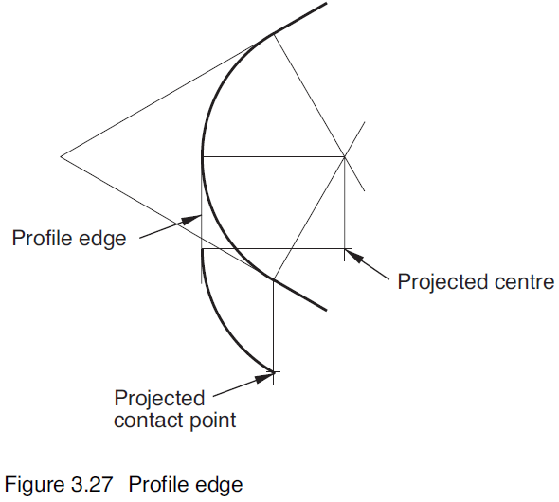

From a vertical plane, no profile edge
The following drawings show the method of projecting a quadrant from a left and a right vertical face. The method is similar to the one described for the horizontal plane, and as such the method will not be described.
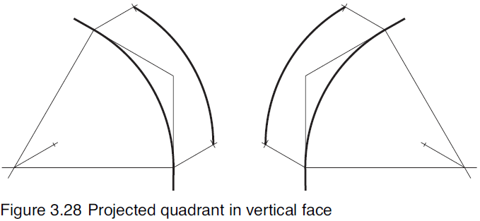
From a vertical plane, with a profile edge
The following drawings show the method of projecting a quadrant from a left and a right vertical face. The method is similar to the one described for the horizontal plane, and as such the method will not be described.
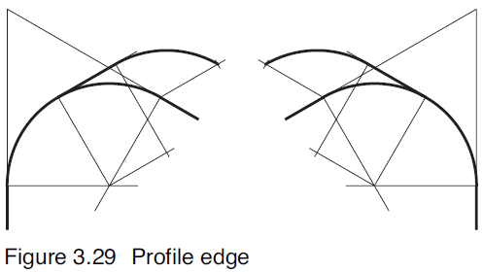
Projecting an isometric quadrant (with a profile edge)

You now have sufficient information to draw isometric circles, either freehand or by using instruments, but you will need a great deal of practice to be able to complete drawings quickly and accurately. Keep these notes as a reference, and use them as often as possible.

Engineering Report
An engineering report is a formal, considered document which draws together information gained about a product or field, through research and analysis, to arrive at a conclusion or present recommendations based on investigation.
Engineers do not communicate with words alone. In an engineering report, technical information is presented using a combination of text, tables, graphs and diagrams.
An engineering report involves:
- Outlining the area under investigation.
- Collecting and analysing available data.
- Drawing conclusions and/or proposing recommendations.
- Acknowledging contributions from individuals or groups.
- Recording sources of information.
- Including any relevant additional support material.
An engineering report involves covering additional aspects such as:
- Examining the nature of the work done by the profession.
- Discussing issues related to the field.

Aims of an Engineering Report
A well-structured engineering report aims to:
- Demonstrate effective management, research, analysis and communication skills related to the content.
- Include data relevant to the area under investigation.
- Present information clearly and concisely so it is easily understood by the reader through the use of tables, graphs and diagrams to illustrate mathematical and scientific facts.
- Justify the purpose using observations, calculations, or other evidence, to support a conclusion or recommendations.
- Document contributions and sources of information.
Structure of the Engineering Report
An engineering report generally includes the following sections:
• Title page
• Abstract
• Introduction
• Analysis
• Result summary
• Conclusions/Recommendations
• Acknowledgments
• Bibliography
• Appendices.

Title page
The title page gives the title of the report, identifies its writer or writers and gives the date when the report was completed.
Abstract
The abstract is a concise statement that describes the content of the engineering report. It covers the scope of the report (what it is about) and the approaches used to complete the analysis (how the information was assembled).
The purpose of the abstract is to allow a reader to decide if the engineering report contains relevant information.
The abstract should be no more than two or three paragraphs – shorter if possible.
Introduction
The introduction provides an overview of the subject, purpose and scope of the engineering report and may contain background information regarding the topic.
It also outlines the sections of the engineering report including why the investigation was undertaken, what research occurred, how data was collected and what anaylsis was conducted.
Analysis
The analysis is the body of the engineering report and should show evidence of research and experimentation. Information about materials and the mechanics of products should be collected or calculated for all engineering reports. This section must contain information required to satisfy the aim and purpose of the report.
Tables and graphs, used to summarise detailed data in a concise form, are common features of an engineering report.
Result Summary
The result summary should present the results concisely and note any limitations on the investigation.
The results inform and support the conclusions and recommendations.
Conclusions/recommendations
The conclusions/recommendations summarises major points or issues in earlier sections of the engineering report.
This section requires the writer to draw conclusions or make recommendations based on data collected. If the purpose of the report was to ‘select the best…..’, then the selection should be stated and the reason for the selection explained.
Acknowledgments
The acknowledgment section provides the opportunity to credit other people’s work that has contributed to the engineering report.
Bibliography
The bibliography demonstrates that the report is well researched. All references need to be included. Bibliographic entries should follow established guidelines.
A standard approach is the Harvard systems of referencing requiring the authors surname initials, date of publication, title of reference, publisher and place of publication. Refer to College assessment schedule for correct Harvard Referencing.
This information allows the reader to source the information for confirmation of the details or conduct further research.

For example:
Text
Kalpakjian, H. R. and Wrighton, H. 1967, Practical Microscopical Metallurgy, Addison Westley, USA.
Website
Wade, Matt (2012) How the Washing Machine Changed the World (web page) http://www.smh.com.au/opinion/society-and-culture/how-the-washing-machine-changed-the-world-20120407-1wi1k.html (accessed on Wednesday the 5th, June 2013).
Appendices
The appendices should contain detail that has been separated from the main body of the engineering report. The information in this section is not essential but enhances the other data. Examples could be engineering drawings of the products being compared where the overall dimensions of the product may not have been part of the comparison in the report, but may be relevant to some readers.
During the engineering course this section may contain a technical drawing and could include information collected from organisations.

Developing an Engineering Report
Research and collaboration are the keys to developing an accurate and informative engineering report.

Research Methods
In addition to popular research methods, like individual input and electronic media, traditional reference materials remain a valuable source of information and include:
  - Textbooks
  - Booklets, brochures and pamphlets
  - newspapers, journals and magazines
  - Websites.

Collaborative work practices
Discussion with colleagues constitutes collaboration and can provide valuable information.
These approaches to research and collaboration can be used by you, along with the Information Technology (IT), to develop your engineering report, as well as for any other research you may need to undertake.

The following website will also assist in constructing your Engineering Report.
http://hsc.csu.edu.au/engineering_studies/reports/6-1/engineering_reports.htm

Briefly outline the purpose of an Engineering Report.
_______________________________________________________________________________________________________________________________________________________________________________________________________________________________________________________________________________________________________________________________________________________________________________________
___________________________________________________________________________

Briefly outline what the purpose of the following headings are in an Engineering Report.
Abstract
__________________________________________________________________________________________________________________________________________________________________________________________________________________________________________________________________________________________________________________________________________________________________________________________________________________________________________________________________

Introduction
__________________________________________________________________________________________________________________________________________________________________________________________________________________________________________________________________________________________________________________________________________________________________________________________________________________________________________________________________

__________________________________________________________________________________________________________________________________________________________________________________________________________________________________________________________________________________________________________________________________________________________________________________________________________________________________________________________________

Conclusion
__________________________________________________________________________________________________________________________________________________________________________________________________________________________________________________________________________________________________________________________________________________________________________________________________________________________________________________________________

